## Physiology Final Review Sheet (17,18, 19, 20, 21)

Chapter 17: Mechanics of Breathing

The process of lung function is **ventilation.** Ventilation is to the lungs as what cardiac output is to the heart, and if cardiac output is blood volume ejected per minute, then ventilation equates to the amount of air per minute.

**Respiratory System Functions**

* **Exchange of gases** between the atmosphere and the blood
* Homeostatic **regulation of body** **pH**
  + **Cellular and interstitial fluid pH are controlled by lungs and kidneys**
* Protection from inhaled pathogens and irritating substances
* Vocalization

**Respiratory System Bulk Flow**

* Flow is regulated by **pressure gradients** of higher t7987io lower pressure. Pressure gradients are generated by:
  + A **muscular pump** creates pressure gradients
* **FLOW is regulated by resistance to air flow** is influenced primarily by:
  + the diameter of the tubes through which air is flowing, like arterioles that regulate blood flow
  + viscosity of air, like viscosity of blood.

**17.1 The Respiratory System**

* The respiratory system is primarily dead end tubes and a closed-loop system.
* Flow of O2 and CO2 is regulated by pressure gradients, much like concentration gradients. However, when talking about gases, what is really meant is the differences in **partial pressure**.
  + **Dalton’s Law**

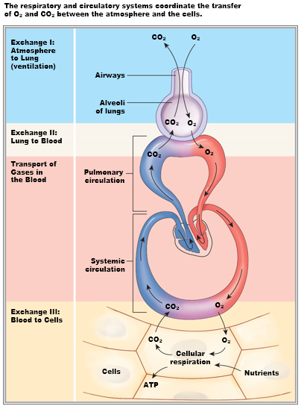

**17.1 Respiratory System (Structures)**

* Superior respiratory tract, nasal passages, and oral cavity have two incredibility important functions: **a) moisten** and **b)** **warms up** air.
  + Oxygen is a hydrophobic molecule that is not likely to diffusion into the watery blood supply. Therefore, to improve diffusion of gases into liquids, moistening the air surrounds the oxygen molecules with water vapors and increasing temperature increases solubility.
* The oral and the nasal cavity converges to the vocal chords and continues into the trachea, which is a tube that is cartilaginous that is collapsible, that then divides into two **primary bronchi** that both diverge into many more branches to increase the surface area up to an 11th branched structure known as **bronchioles** (211 amount).
* **The right lung has three lob**es, and the **left lung has two lobes.**

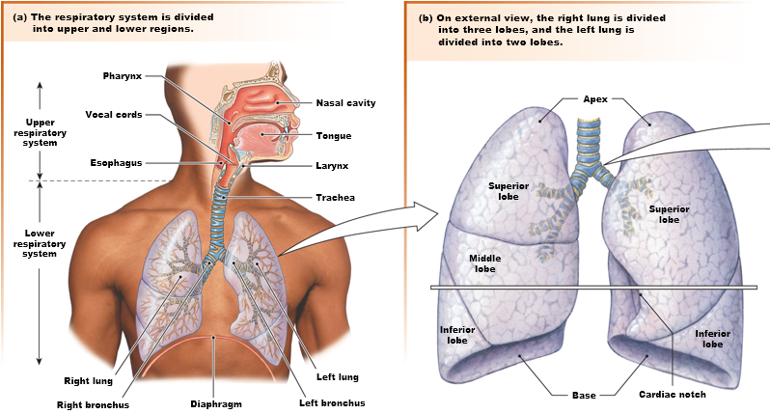

**17.1 Respiratory System (Structures) – (cont.)**

* Surrounding the lungs is the **thoracic** **cavity**.
* There are muscles that control the volume of that cavity.
  + External intercostal muscles when contracted *expand* the cavity.
  + Internal intercostal muscles when contracted *pull rib together* and *“squeeze”* that cavity.
  + Also, the **diaphragm** controls the volume of that cavity as well.
* The **sternocleidomastoids** and the **scalenes** are muscles that pull up the clavicle and two anterior ribs.

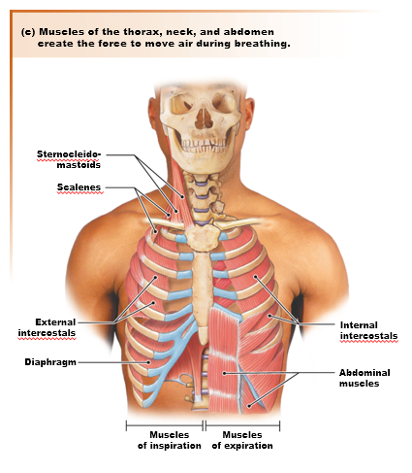

* [Repeat] The trachea bifurcats into 11 levels of division that **increases area of exchange**.
  + A single **bronchiole**, unlike the bronchi and trachea has a very thin wall.
    - **0.5 – 1mm diameter**
  + Each bronchiole ends in a *dead end* in a broccoli floret that is called the **alveolus (alveoli)**

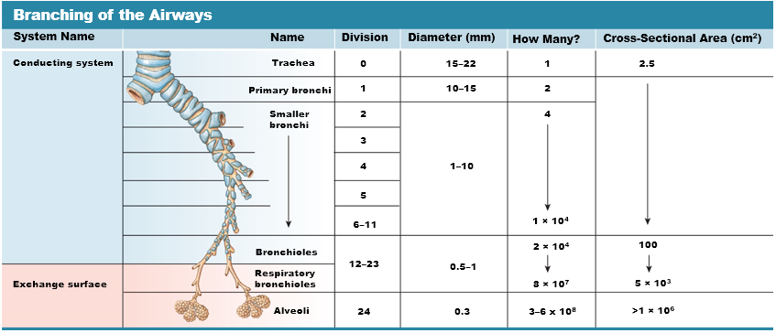

* Each alveolus is **highly vascularized** and **one cell thick with a basal lamina**, much like capillaries, and therefore is the site of gas exchange.

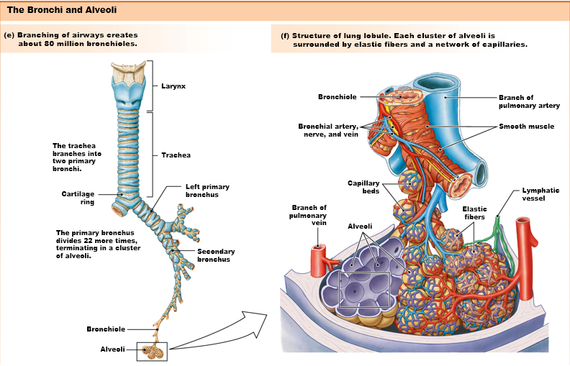

**Exchange Surface of Alveoli**

* Between the capillary and alveolus is a **very thin layer of interstitial fluid.** This separation is as small as 5um up to 1.5um (?????), which is smaller than a cell.
* Changing the gap or distance between the capillary and alveolus will cause changes in the resistance in oxygen and CO2 diffusion, and we call this **edema**.

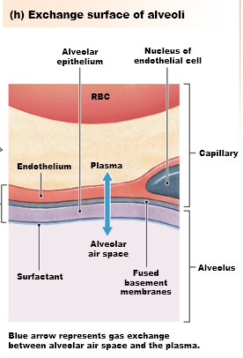

Alveolar Structure (Two Types of Endothelial Cells: Aveolar)

* Type 1: Cells that just make the wall of alveolus and intercalate blood vessels.
* Type 2: synthesizes **surfactants**.
  + Surfactants are incredibly important. WHY? . . .

**Figure 17.3 The pleural sac**

* Firstly, recall that the heart is surrounded by a little bag known as the **pericardium**.
* The lungs are covered by a double “baggie” known as the **pleura** membranes that is filled with fluids that only has 20mL of liquid compared to the 3L of liquid that the lung can hold.
  + This 20mL is stretched around the lungs creating an extremely thin flim that separates the membrane side facing the lungs **(visceral)** from the **(parietal) pleural**. **(What is the importance of the liquid inside the pleura?)**

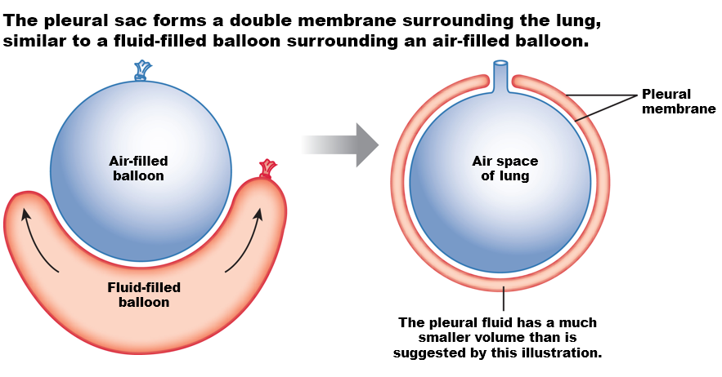

**Figure 17.5(a-b) Airway epithelium**

* In the trachea, there is an epithelium is a single layer but gives a fake impression of multiple layers because the nucleis are in different positions known as **pseudostratified epithelium**.
  + Epithelial cells have **cilia** and are responsible for creating a current as they beat that carries **mucous** upwards, which is secreted by **goblet cells**.
  + Thus, the trachea is lined by pseudostratified-ciliated epithelium intercalated by goblet cells that secrete mucous.
  + It is the upward current that gets the mucous out.
* One of the main functions of mucous is preventing microorganisms, pathogens, irritants, toxic things from getting into the airways.

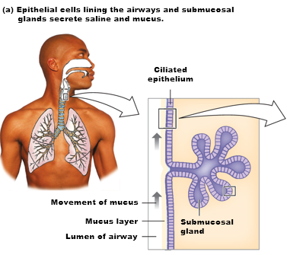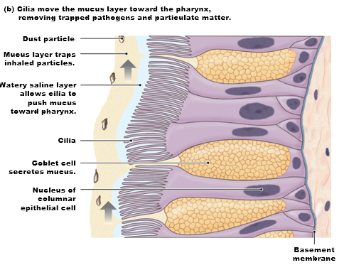

**Mucous and Cilia CANNOT Interact**

* If mucous touches cilia, then cilia will cease to function properly.
* What cilia really moves is saline (thin water film), and when cilia beat it pushes the mucous upwards due to the water current.

**How is the saline layer formed? There is a system that creates a flow of chloride outwards.**

* Chloride is more concentrated in the **extracellular fluid**.
* Chloride enters the cell via the action of **NKCC (Sodium Potassium, Chloride, Chloride symporter.**
* Chloride exits from the apical membrane due the presence of **anion Cl- channels in the apical membrane**.
* As chloride exits, sodium follows chloride **paracellularly** (differences in charge I guess).
* Water follows by osmosis due to the flow of sodium to the lumen, which forms the saline film/layer.
* (To maintain the process of Cl- flow, since there’s no apical channels for sodium or potassium in the apical membrane, the presence of **Na+-K+ ATPase and leaky potassium channels** are a recurrent theme in maintaining crucial processes).

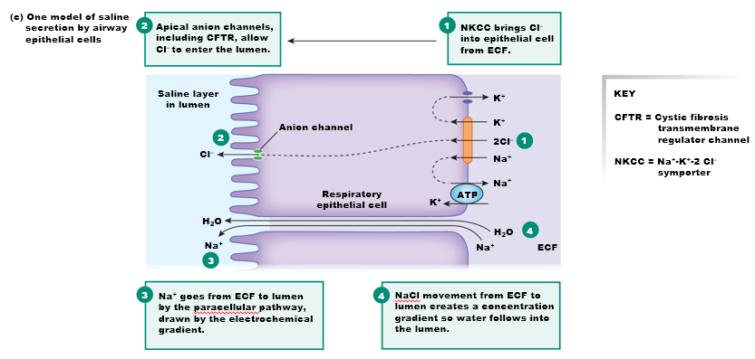

Why is the anion Cl- channel called **the cystic fibrosis channel** **(CFTR**)?

* **Mutation of the Cl- anion channel, or the CFTR** will lead to no production of saline layer, and the constant manual clearing of the throat, leading to thickening of the wall of the trachea, inflammation, injury, and as a response fibrosis of that tissue.
  + This mutation is one of the most common causes of lung disease.
  + Lung fibrosis is only one of the issues, and when studying the **kidneys, CFTR has relevance there as well**.

**Figure 17.6(a) Gas Laws (Ideal Gas Equation and Boyle’s Law)**

* PV = nRT, but in humans, R (universal gas constant), T (temperature in Kelvin), and n (number of moles) are constant.
* **V = 1/P**
  + **Volume is inversely proportional to pressure**.
    - Bigger alveolus = smaller pressure
    - Smaller alveolus = greater pressure\
* V = 1/P is only when the surface tension is **not** considered.

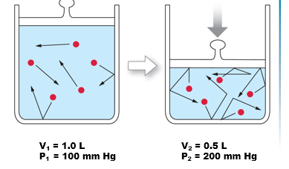

* **P1V1 = P2V2 (Boyle’s Law)**
  + Like above, also expresses pressure and volume express inverse relationship.

**Dalton’s Law (Partial Pressure of a Gas is a combination of oxygen, CO2, and water, and you should subtract the pressure of water before multiplying with the percentage of oxygen).**

* Pressure dictates flow, pressure gradients.
* Quantification of concentration of gases in fluids can be related by the partial pressure of that gas.
* Atmospheric gases are quantified by a combination of multiple gases.
  + 760 mmHg = 1atm
  + CO2 is 0.03% of the atmosphere.
  + Oxygen is 21% of the atmosphere.
  + 760 mmHg x 21% = 160 mmHg of oxygen (IF THE AIR IS COMPLETELY DRY)

**Dalton’s Law in 100% Humidity (The amount of Water Vapors in the Air)**

* 100% humidity means a water vapor of 24 mmHg.
* Therefore, water vapor needs to be accounted for.
* (760 – 24 mmHg) * 21% = 155 mmHg
  + (Though the most accurate way is to also account for CO2, but it’s nothing.)
* The point made here is that the amount of oxygen in the air is less in 100% humidity.

**Dalton’s Law: Consider 100% Humidity and Increased Temperature**

* Increased temperature increases solubility of water vapors, increasing the partial pressure of water vapors even more and decreases the partial pressure of oxygen.

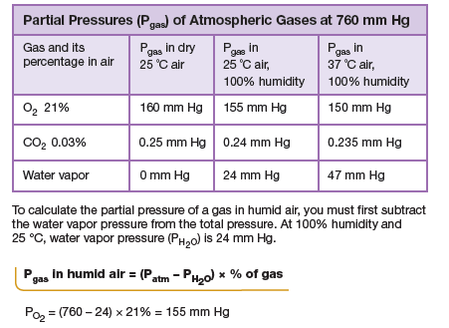

EXAM: Calculate partial pressure of oxygen in different scenario and dictating which one is better for oxygen diffusion

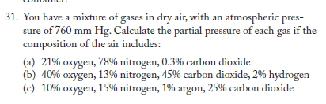

**Figure 17.7(a) Pulmonary function tests**

* Lung function: Ventilation = (rate of breath) x (volume of air that is inhaled and exhaled) . . . passively
  + This is about 500 mL of air, which is **tidal volume, which is passive breathing ventilation** .

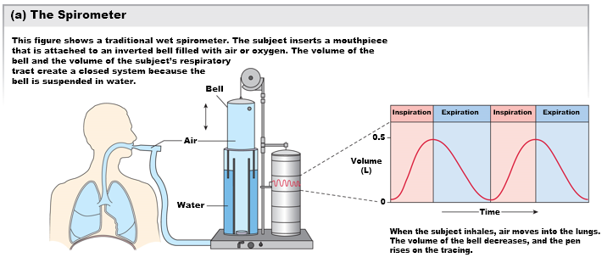

**Figure 17.7(b) Pulmonary function tests**

* **Tidal** **volume**: oscillations are 500mL.
* **Expiratory** **reserve**: at the bottom of passive exhalation, then forced exhalation, is about 1.1L of air.
  + Notice that the expiratory reserve is much smaller than the inspiratory reserve, that is because there is **residual volume** for the same reason as why a blood can’t have 0 mL of blood because we cannot collapse our lungs completely.
* **Inspiratory** **reserve**: at the top of a passive inhalation, then forced inhalation, is about 3L.
* **Vital Capacity**: Tidal + Inspiratory Reserve + Expiratory Reserve
* **Total** **Lung** **Capacity**: inspiratory, expiratory, and tidal volume, **(AND RESIDUAL VOLUME)**
* **Functional Residual Capacity**: ERV + (Residual Volume)

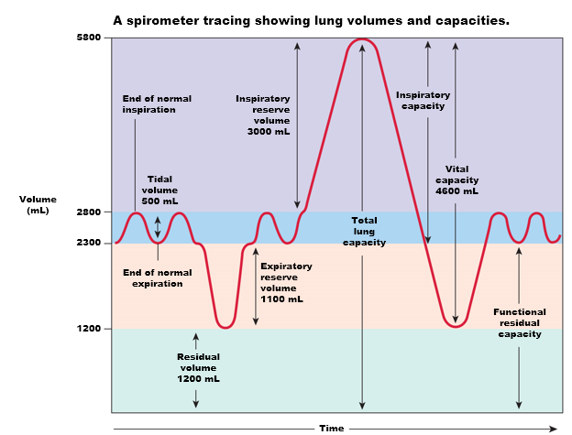

**Can you increase your vital capacity? Can you make your lung more elastic?**

* Aerobic exercise.

On the flip side,

* Coach potato lifestyle, pathological things, killing cells that produce elastin, decreasing collagen, smoker,

Figure 17.8 Pressure is regulated by the movement of the thoracic cage and diaphragm during breathing

* External intercostals contract and causes thoracic cavity to expand.
* Diaphragm when contracted expands the thoracic cavity as well.
* (We thought that these two muscles were enough, but now we realize that in patients who **lose** **scalene function**, when their diaphragm contracts, their thoracic cavity actually decreases at the bottom, working against inspiration. You can see this happen as the diaphragm contracts and is pulled down, the lower rib cage is also pulled down with it. )
* Expanding the thoracic cavity is going to pull the parietal side of the membrane with it.

**Expanding the thoracic cavity will pull the parietal side of the pleural membrane with it**.

* The pleural has two membranes and a liquid between them. Similar to putting two glass pieces between water, making them almost impossible to separate.
  + **The parietal side (outer side) therefore pulls the visceral side (inside) with it.** 
    - The visceral side is attached to the lungs.
* The lungs cannot expand or contract on their own. They passively do so by the expansion and retraction of the thoracic cavity, and by the function of the pleural membranes connected by pleural fluid.
* **Inspiration occurs when increasing volume decreases pressure, so air will flow inside, and if the cavity is squeezed, higher pressure inside will cause air to flow out.**

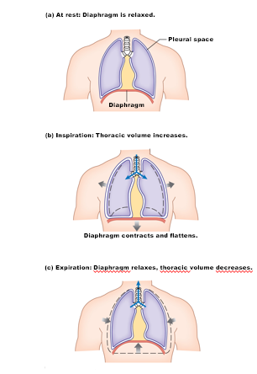

**Figure 17.9 Pressure changes during quiet breathing**

Looking at the graph,

* The alveoli pressure starts at zero, meaning the alveolar pressure equals the atmospheric pressure: NO FLOW.
  + The time in-between breaths when there’s no inhalation or exhalation, at this precise time, pressure is equal.
* INSPIRATION
  + Thoracic cavity: EXPANDS
  + Alveolar pressure: DECREASES => draws air in => which causes pressure to increase again and equalize with the atmospheric pressure (which explains why the differences in pressure is going back to zero).
* EXHALATION: squeeze with intercostal muscles and abdominal muscles
  + Thoracic cavity: DECREASES VOLUME
  + Alveolar pressure: INCREASES = > air will flow out => which causes pressure to decrease again back to a difference of 0.
* Intrapleural Pressure: (pressure in-between the perietial and visercal pleural filled with liquid)
  + Membrane develops in a way that the outer membrane develops much faster than the inner membrane. This creates a vacuum, so much that the intrapleural pressure is always negative compared to the atmospheric pressure (-3mmHg difference)
    - Inhalation causes the intrapleural pressure to go to -6 difference).
      * **Pressure differences in intrapleural pressure is the main driving force for what causes the change alveolar volume**.
        + **The alveolar doesn’t have smooth muscle, and the alveolar itself cannot contract or relax**. It can only obey the pull and push of the pleural membrane.

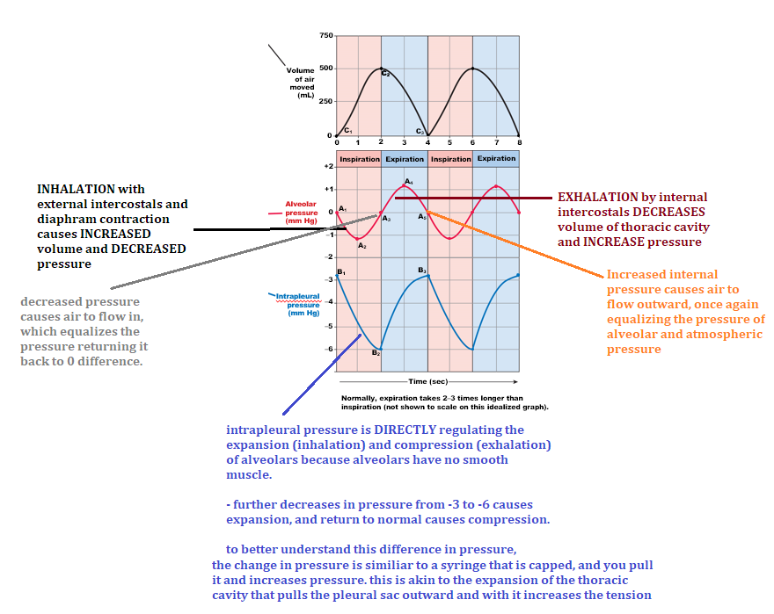

What is **pneumothorax**?

* Perforation through the pleural sac causes a loss of the vacuum, so inhalation will only cause the outer membrane to expand, while the inner membrane doesn’t move. Loss of this negative pleural pressure means that lungs will not expand.

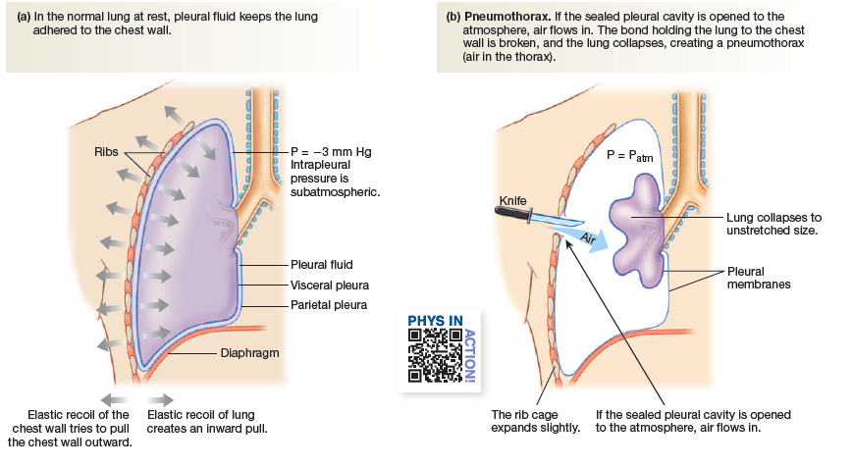

**Lung Compliance and Elastance May Change in Disease States**

* **Compliance**: ability of the lung to expand as the thoracic cavity expands.
  + High compliance: easily stretches
  + Low compliance:
    - Requires more force
    - Restrictive lung disease: **decreased lung compliance affects ventiliation because more work/energy is needed to expand the lungs**.
      * **Fibrotic lung disease**: . . . more fibrous tissues because for instance mutations in the NKCC channel (chloride), leading to lesions in epithelium and macrophages that secrete growth factors that stimulate fibroblasts to produce inelastic collagen—leading to pulmonary fibrosis. This can also be caused by inhalation of asbestos and silicon, or inorganic substances.
        + **Tl**;dr stiff, fibrious scar tissue restricts lung inflation
      * **Inadequate surfactant production (NRDS)**
        + **[More on this below.]**
* **Elasticity**: allows for the lungs to recoil as you stop expanding and now decrease thoracic volume.
* THERE IS A TUG-A-WAR between compliance and elasticity.
  + **Smokers have more compliant lungs but less elastic ones.**
    - Therefore, exhalations are shorter; CO2 accumulates as a consequence.

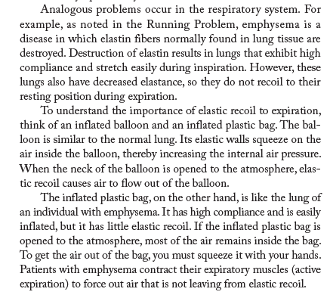

**Surfactant Decreases the Work of Breathing (EXAM)**

* Lung tissue itself doesn’t contribute as much resistance as once thought.
* The property that infers the most resistance is **surface tension** created by a thin fluid between the alveolar cells and the air. Surface tension arises because of hydrogen bonds between water molecules. This creates pressure that is directed towards the middle of the “bubble.”
* This is similar to the fluid lining in all alveoli that creates surface tension.
* **Surfactants** displaces water molecules and decreases the amount of hydrogen bonds. This decreases the inwardly directed pressure which increases compliances, making it easier and less energy-costly to breath.
* **LaPLACE Law:**
* **If pressure is inversely proportional to volume,** 
  + **Smaller alveolar has greater pressure, and therefore is less compliant than a bigger alveolar.**
  + **THEREFORE, small alveoli is GREAT for gas exchange, but terrible for compliance—they resist expansion more because of the surface tension of water.** 
    - **Nature’s solution: surfactant from type 2 alveoli cells** 
      * **Notice that decreased tension, when looking at Laplac law, pressure is the same even when size is different. Therefore, small aveloi are made more compliant.**

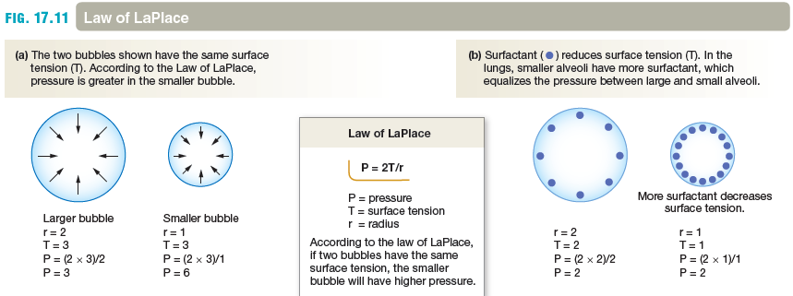

CURSE OF THE KENEDEY’S (EXAM)

* **Blue Angel Disease:**  Premature babies were dying, and people had no idea why. If you catch these babies before they die, they’re pretty much blue and gasping for air because their alveoli are collapsed.
  + **WHY?** Pre-mature babies do not produce enough **prostaglandin E.** 
    - Signaling from prostaglandin E produce surfactants. Furthermore, this is important for scarring of the two lung bypasses in fetal.

**Airway Diameter Determines Airway Resistance**

* Pressure and viscosity of air affects flow.
* Also, **airway diameter also affects flow.**
* Bronchioles are surrounded by smooth muscle.
  + **Most of** ventilation is controlled by parasympathetic pathways.
  + **Acetylcholine** on **smooth lung tissue**, causes bronchile constriction (which is the same as “vaso”constriction” on **M3 muscarinic receptors, which are Gq coupled => contraction => narrowing of bronchioles.**
  + Nerves that control the bronchioles (**pulmonary neurons**) have M2 muscarinic receptors, which means the post-ganglionic cell in response to ACh will stop working…so if you release ACh into the post-ganglion cell, it will cause relaxation of bronchioles because it’s preventing secrection of ACh by the post-ganglionic cell.
  + But the primary function of the parasympaethic system is to cause bronchiole construction.
  + There is NO classic sympathetic regulation of the bronchioles. There is no sympathetic NERVES controlling your lungs.
    - But, guess what, epinephrine is circulating the blood, and there are **beta-receptors in the bronchiolar smooth muscles that cause vasodilation because of cyclic AMP production => inhibition of MLCK.** 
      * So the sympathetic response of the sympathetic response is bronchodilation, which is why people carry epi-pens.
  + **CO2 relaxes bronchioles as well. (excess CO2 opens airways so CO2 out and O2 in.**
  + **Histamine is a bronchoconstrictor…and it makes sense, doesn’t it? Not really, man…**

**Rate and Depth of Breathing Determine the Efficiency of Breathing**

* Total **pulmonary ventilation**
  + Volume of air moved in and out of lungs per minute
    - **Ventilation = [rate × tidal volume]**
      * **12 x 500 mL = 6L/minute HOWEVER!!**
* Consider **the DEAD SPACE**, which is the NON-CONSTRICTABLE air (DEAD AIR)
  + When you inhale 500mL of air , not all of that gets into your alveoli.
    - Hose analogy.
  + **Alveolar ventilation (More accurate)**
    - **Ventilation = (rate) × (tidal volume − dead space) [EXAM]** 
      * **So the tidal volume is really only 350mL not 500mL)** 
        + **This person vs that person: this BPM and this dead air, which one is doing better, which one is getting better oxygen**

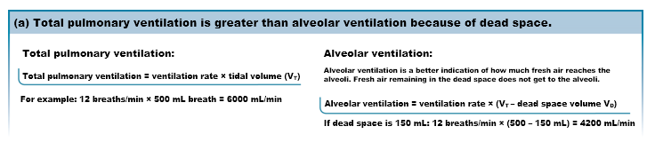

## Chapter 18: Gas Exchange and Transport

Introduction to Gas Exchange

* The body needs oxygen and removes carbon dioxide
  + **Hypoxia** – too little oxygen (more common)
  + **Hypercapnia** – increased concentrations of carbon dioxide
* **To avoid hypoxia and hypercapnia, the body responds to three regulated variables**
  + **Oxygen**
  + **Carbon** **dioxide**
  + **pH**

Figure 18.1 Pulmonary gas exchange and transport

* In the alveolar base, oxygen partial pressures, the gradient, favors diffusion into the capillary circulation, and the opposite for CO2.
* No more gas exchange occurs until capillaries are reached. This makes sense because you need one cell thin layers for gases to diffuses across.
* CO2 is transported in THREE different forms:
  + Bicarbonate (most common)
  + Can be bound to protein side of red blood cells called hemoglobin.

Table 18.1 Classification of Hypoxias

* **Hypoxic** **hypoxia**: low arterial PO2
  + Typical causes: high altitude, alveolar hypoventilation; decreased lung diffusion capacity
* **Anemic** **hypoxia**: low count of red blood cells (technically hemoglobin), which allows for O2 to be bound)
  + Typical causes: blood loss, anemia (low [Hb] or altered HbO2 binding); carbon monoxide poisoning.
* **Ischemic** **hypoxia**: restriction of blood flow to tissue; and as a consequence, that tissue will be hypoxic
* **Histotoxic** **hypoxia**: poisoning, by contamination of irritants that may either cause all of the three above.
  + **For example**, poisoning mitochondria with cyanide on complex 3.

Table 18.2 Normal Blood Values in Pulmonary Medicine

* **Notice**, **drop in oxygen partial pressure from arterial to venous** is indicated due to when oxygen diffuses out of arteries into the tissues.
* **Notice, the gradient of PCO2 is much narrower.**
* **Notice, the veins are a little more acidic, why?**
  + - If you blow through a straw into phenol red because
      * FIRST, CO2 + H2O => H2CO3 (carbonic acid) => H+ + HCO3-
      * 2nd CO2 by the action of **carbonic anhydrase.**

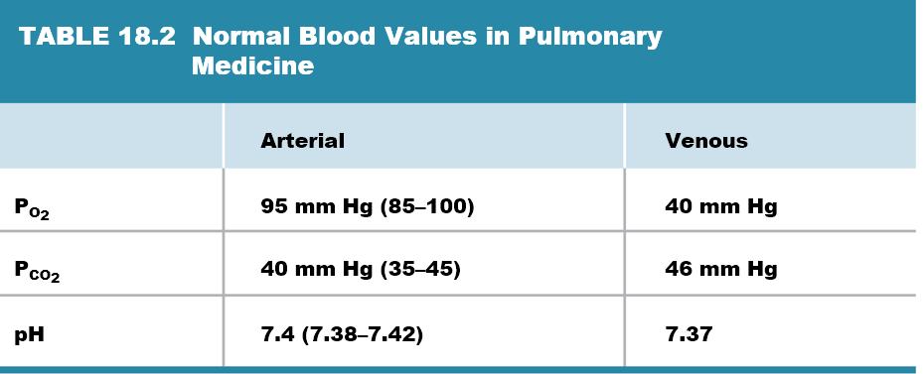

18.1 Gas Exchange in the Lungs and Tissue

* If you multiple 760 atm x 21% = 160 mmHg in DRY air.
* But if we saturate the air with 100% water
  + (760 – 24) * 21% = 154 mmHg ~
* The partial pressure here favors oxygen diffusion into the arteries, and this happens at such a constant rate that the partial pressure in the other side of the alveolus is already 100 mmHg.
  + You might ask yourself, **well how come oxygen diffuses, if diffusion occurs by a gradient?** 
    - If both the arteriole end and the alveoli have 100 mmHg of pressure, then how does diffusion occur? The answer lies in the schematic, constant flowing of blood through the capillaries that is carrying away oxygen that just diffuses in. So **there’s a slightly smaller partial pressure of oxygen in the capillary circulation right before it arrives in the alveolus.**
* Why is CO2 diffused into the blood?
  + PCO2 in the venous part is 46 mmHg, and PCO2 in arterial blood is 40 mmHg, which favors diffusion of CO2 into the circulation.
* Why is O2 favored into the cell?
  + Same reasoning.

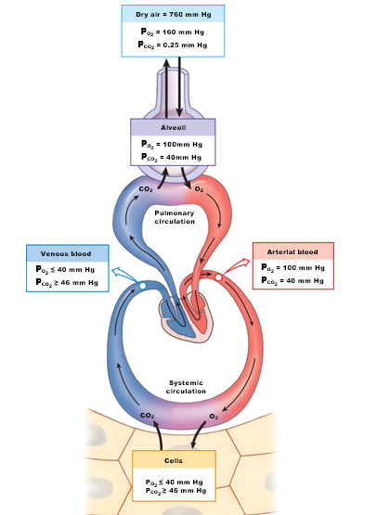

**Diffusion Problems Cause Hypoxia**

* In **emphysema**, decreasing alveolar surface area decreases the area for gas exchange. **=>** lower oxygen diffusion.
* In fibrotix lung disease, thickening of the alveolar membrane from inflammatory diseases or mutation the **CFTR** will decrease lung compliance and therefore decrease alveolar ventilation
* In **pulmonary** **edema,** increasing the space that is the interstitial fluid between the capillary and alveolar will *prevent or disturb* the process of gas exchange.
* In **asthma**, narrowing of the bronchial tubes
  + Resistance to flow is contributed by the width of bronchioles (narrow = less air), and viscosity of the inspired air.

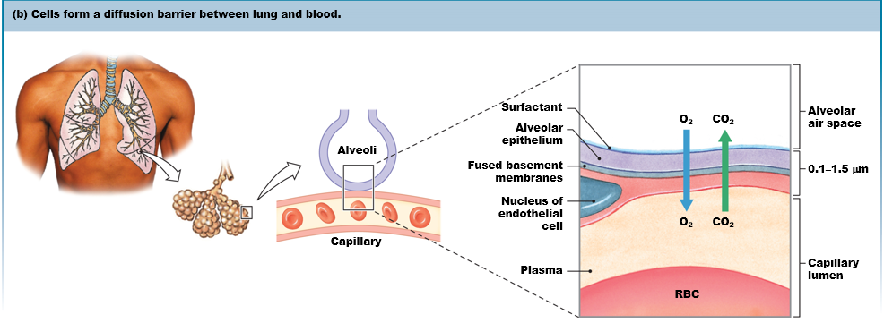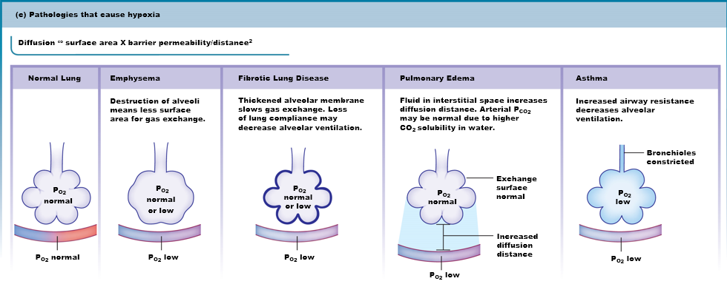

Gas Solubility Affects Diffusion

* If you let a bottle of O2 equilibrate over time, the partial pressure of the gas outside and inside will be the same. **BUT partial pressure does NOT equate to concentration**.
* Comparison between CO2 and O2**, SAME partial pressure shows that CO2 is about 20 times more soluble than O2.** 
  + In 100 mmHg = [O2] = 0.15 mmol/L in water.
  + In 100 mmHg = [CO2] = 3.00 mmol/L in water.
  + CO2 is NOT hydrophilic, just relatively speaking

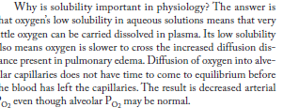

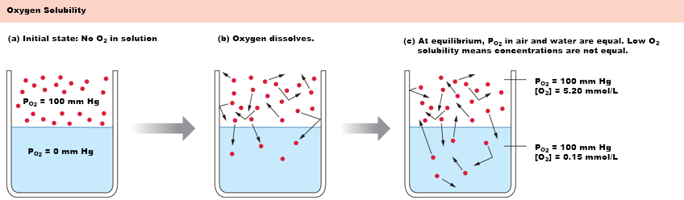

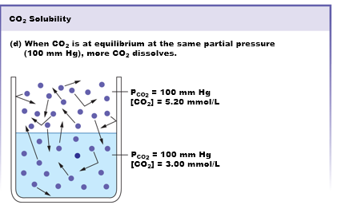

18.2 Gas Transport in the Blood

* Dissolved gas accounts for less than 2% of all oxygen in the blood.
* 98% is trapped in a protein known as hemoglobin.
* Fick equation
  + **Oxygen consumption (QO2) = CO × (Arterial [O2] – Venous [O2])**
    - Think about this logically.
    - If the cardiac output is **5.2L**, multiple that to [this guy]
      * Oxygen consumption = 250 mL of oxygen per minute is what your tissue at rest is consuming.
* **250 mL O2/min oxygen consumption is an interesting value to think about with respect to oxygen concentrations purely by its solubility (which is low).** 
  + If you consider the partial pressure of oxygen alone and solubility of oxygen, **blood without hemoglobin**, will only have about 15-20 mL of oxygen per liter of blood; but your tissue is consuming 250… **we could not survive without the presence of hemoglobin**. Why?
    - Because of the rate that it diffuses is not enough.
  + Tl;Dr **– the advantage of coupling oxygen to hemoglobin is good.**
* Hemoglobin has 4 heme groups. Each molecule of hemoglobin therefore can bind to four hemoglobin at once.
  + This binding obeys the law of mass action.
    - If there’s a lot of oxygen in the blood, increasing binding to hemoglobin. And let’s say there’s a lack of O2 in the tissue, so when hemoglobin is close to tissue, mass action favors delivery of that gas—removal of the molecule.

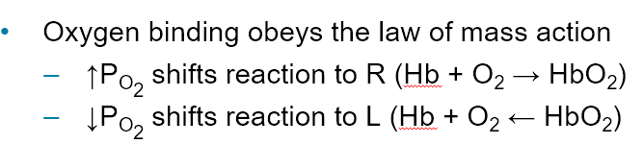

Gas Transport in the Blood

* Red blood cells are actually rubbing against the wall of capillaries.
* HOW DIFFUSION WOULD HAPPEN IN DIFFERENT AMOUNTS OF HEMOGLOBIN SATURATION. 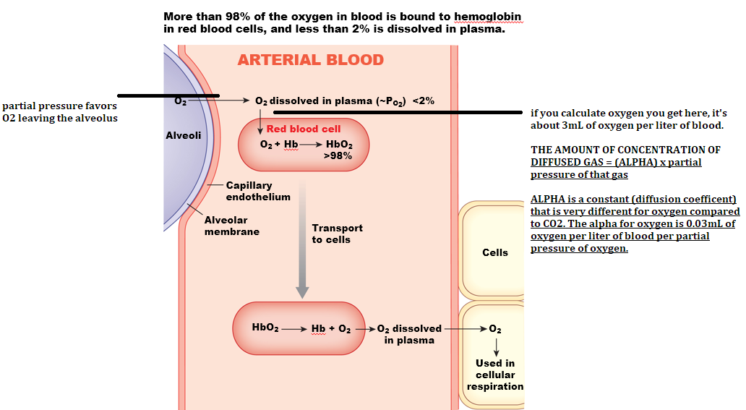

**Gas Transport in the Blood (CALCULATIONS) [EXAM]**

* **Concentration of diffused gas = (alpha) x ( [PO2] )** 
  + **Where alpha = 0.03 for O2**
  + **ASSUME [PO2] = 98 mmHg**
  + **(0.03)(98) = 2.8 mL of O2 in the blood.**
* **But if hemoglobin is saturated 100%, meaning that each hemoglobin has 4 oxygen bonded, the oxygen diffused in the plasma is the same, 2.8mL O2/liter of blood.** 
  + **But now you have 197mL O2 in the hemoglobin, and now you have 200 mL of oxygen in the blood.**
    - **And if you multiple that by the (cardiac output), you get about 1.0L of oxygen potentially able to be delivered to tissues, FOUR TIMES higher than the resting consumption rate of tissue (which is 250).**
  + **In (c), if only 50% saturation, there’s still 100 mL O2/L blood, highlighting the efficiency of oxygen transport due to Hb.**

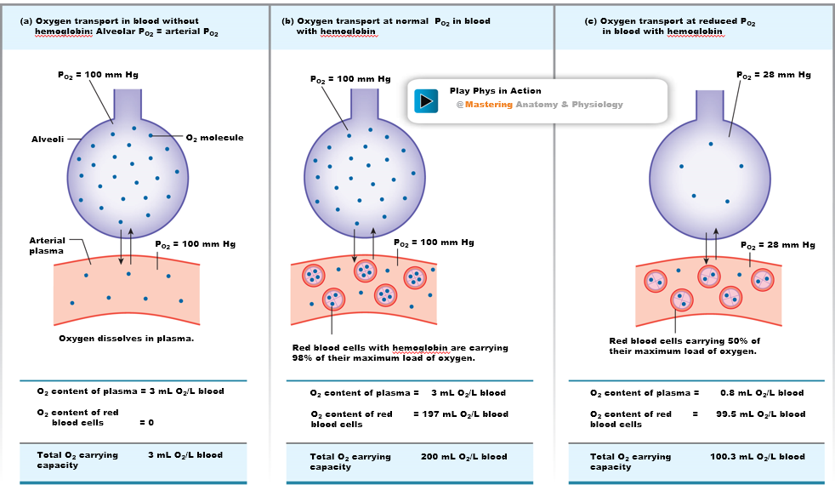

* The above example talks about oxygen**, but this could also be CO2**
  + **The partial pressure of CO2 is 40 mmHg.**

**Figure 18.9(a-b) Oxygen-Hemoglobin Binding Curves**

* At RESTING cell PO2 = 40 mmHg, hemoglobin is only at 75% saturation, which means that hemoglobin is only delivering 25% of their capacity to the tissue.

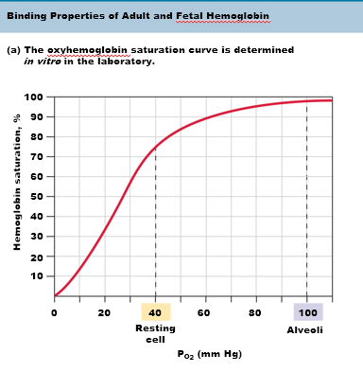

* Delta **is replaced with gamma**. Gamma has a higher affinity of oxygen. So at 40 resting, the maternal hemoglobin has only 75%~ saturation, while the fetal with the gamma has about 90%~ saturation, **which is important because it allows for hemoglobin to better trap oxygen molecules—where in the placenta the partial pressure of oxygen is only 20 mmHg not 40 mmHg.—so then oxygen can be carried into fetal circulation.** 
  + **PO2 in the placenta**

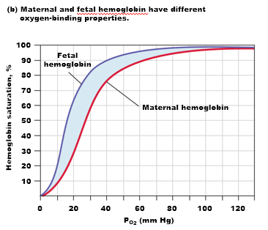

Several Factors Affect O2-Hb Binding

* pH:
  + HIGHER pH => higher affinity of hemoglobin
* Temperature
  + COLDER temperature => higher saturation
* CO2
  + MORE CO2 => the LESS oxygen saturation
    - This is because the Hb are delivering MORE oxygen to a high partial pressure of of CO2
  + CO2 and oxygen COMPETE for binding to hemoglobin. **CO2 actually has a HIGHER** affinity than oxygen for Hb.
* **2,3-BPG (biphosphoglycerate) [EXAM!!!]** 
  + Metabolic intermediate in the glycolytic cycle.
    - When CO2 rises, and as a result pH drops (due to carbonic acid dissociation), red blood cells accumulate 2,3-BPG.
      * 2,3-BPG drops saturation dramatically (causes oxygen to dissociate from Hb) – think about it, it’s logical.

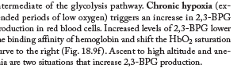

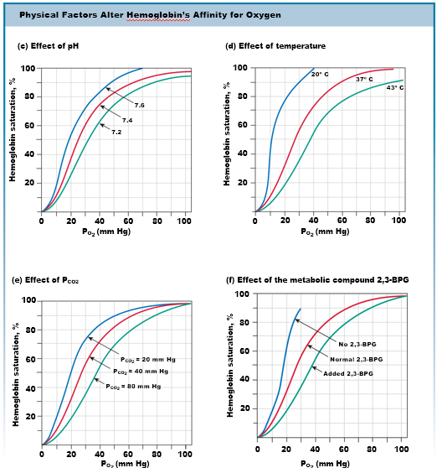

Carbon Dioxide Is Transported in Three Ways

* CO2 diffuses out of cells into systemtic capillaries.
* 1) Some CO2 is bound to hemoglobin (about 23%), and
* 2) about 7% is just DISSOLVED into the plasma and its cycling between carbonic acid, bicarbonate, and CO2
* 3) The vast majority of CO2 is IN the cytosol and is exchanged with a **chloride-bicarbonate exchanger through the plasma membrane**.
  + Which is important for removing CO2 from the cytosol.
  + BECAUSE there’s a higher affinity of CO2 to hemoglobin, CO2 accumulates in the RBC, but for it to diffuse out of the cell, it must be converted into bicarbonate.
    - WHY?
      * Because CO2 has a higher affinity than oxygen.
* AT THE LUNGS: (the opposite will happen)
  + In the lung circulation, a) the antiporter brings bicarbonate back.
  + B) the bicarbonate combined with water through the action of **carbonic anhydrase** will convert bicarbonate back into CO2 and water.

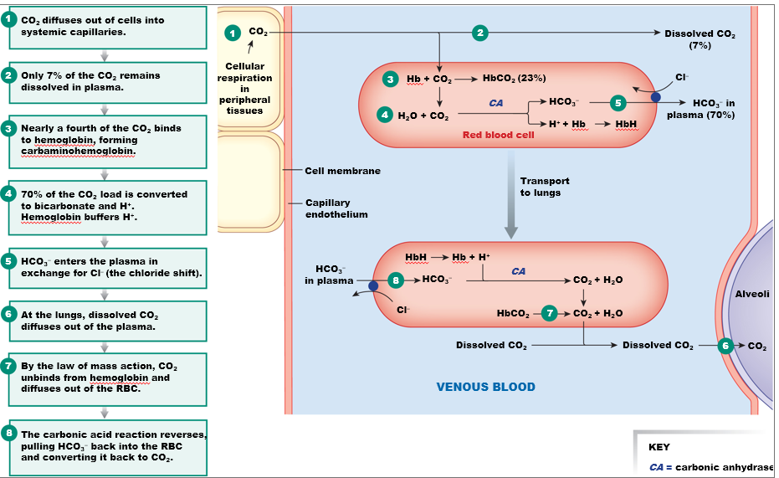

* We know that it’s not only the amount of gas dissolved in the plasma, BUT ALSO THE AMOUNT OF GAS IN HEMOGLOBIN.
  + AND THAT’S BEING ADDED TO THE PICTURE
    - 98% of oxygen is found in hemoglobin
    - 2% is dissolved.

Figure 18.12 Summary of O2 and CO2 exchange and transport

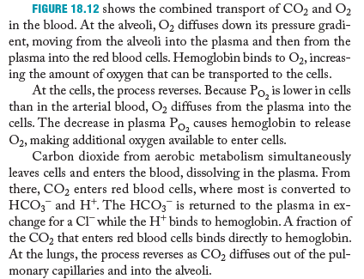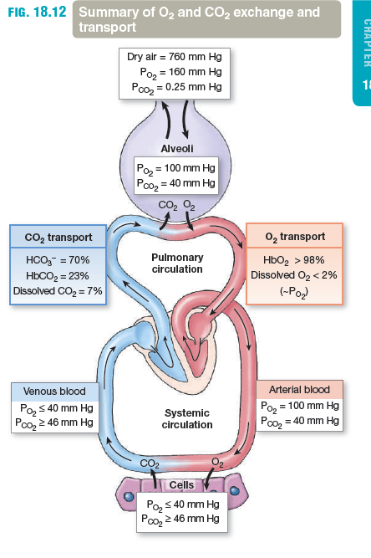

EXAM QUESSTION

* Hematocrit was measured and the amount of hemoglobin in the blood.
* Patient has **13g of hemoglobin per 100 mL of blood.** (or **130g/L of blood**
* The saturation of Hb is sO2 = 95%.
* Calculate the total oxygen content in this patient.
  + Assume this is arterial circulation and that the pO2 = 100mmHg.
* Also calculate unbounded oxygen and then add the two together.

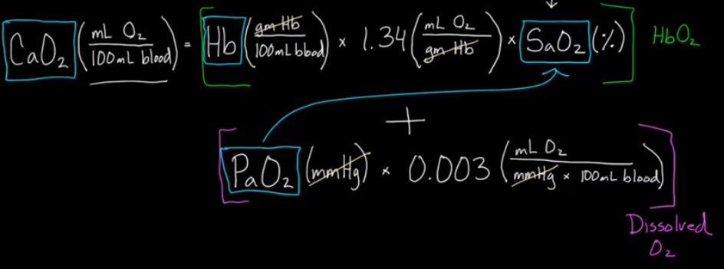

CONSIDER THE CENTRAL NERVOUS SYSTEN CONTROL OF VENTILIATION AND THE FACTORS THAT INFLUENCE IT.

18.3 Regulation of Ventilation

* Signals in the high brain centers is
  + **Emotions** and makes u hyper or hypoventilation.
* Concentration of CO2 and oxygen in the plasma are chemical signals that are perceived by **medually or pherperial receptors.**
  + **MEDULLARY RECEPTORS RESPOND TO CO2 LEVELS, BUT REALLY HYDROGEN, protons----to pH, really pH centers.**
    - **But as we understand, a low pH reflects a high pCO2.**
      * **CO2 + H2O => carbonic acid => proton + bicarbonate**
        + Low pH, acidosis—reflects **hypercapnia.**

**What is this**?

* Carotid and aortic chemoreceptors respond to OXYGEN pressures (pO2). => activate afferent sensory neuron => talk to medulla oblongata => motor neurons efferent => that command inspiration or expiratory muscles.
  + Afferent sensory neurons talk to medulla and depending on who the interneuron is, it could be inspiratory or expiratory muscles activing. THIS IS THE GIST OF HOW VENTILIATION IS CONTROLLED.
* 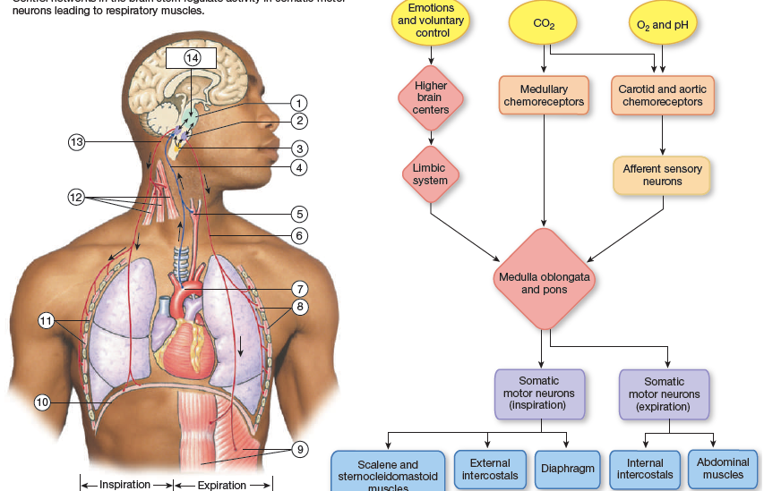

Neurons in the Medulla Control Breathing [EXAM] [not rlly I just starred it] (more autonomous regulation…)

* PRG: lose ability to coordinate breathing with emotions, anxiety and whatnot.
  + THIS IS NOVEL IN EVOLUTION, the other parts of ancient.
* DRG (dorsal): involved in controlling diaphragm via the **phrenic nerve**.
* VRG (ventral): involved in expiratory muscles
  + A section of pacemaker cells known as the pre-botzinger complex sends signals to DRG to breath. This is why we breath involuntarily or automatically.

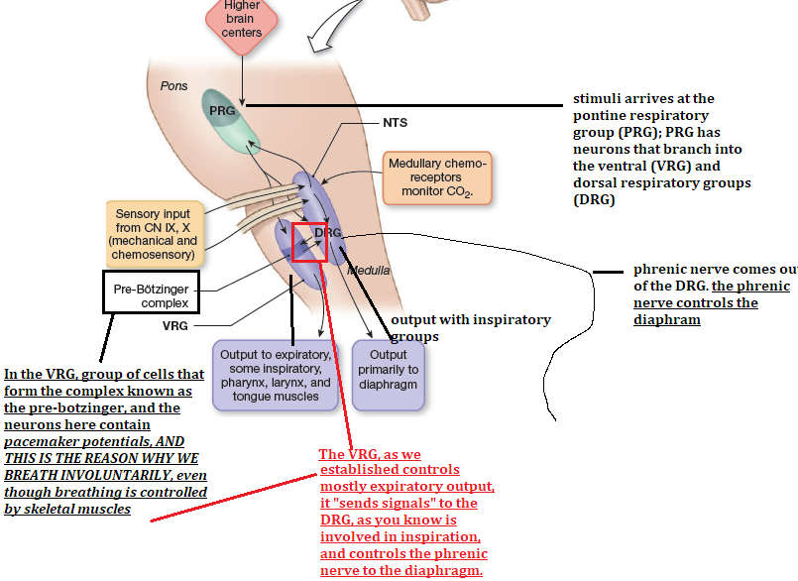

CO2, Oxygen, and pH Influence Ventilation (how do the “sensors talk to these guys” wtf)

* HOW DO THE VENTRAL AND DORSAL RESPOND TO CO2 levels?
* There are chemo senssors in there.
* And how do these groups respond to the oxygen sensors respond in the aorta arch, right next to the baroreceptors, btw, and the coratids.
* It is through the function of a speaclized cell known as the **glomus cell**.
  + The glomus is an oxygen sensor. When oxygen levels drop—low oxygen levels “somehow” causes
    - 1) potassium leak channels to close in the cell
    - 2)as a result, depolarization occurs.
    - 3) opening of VG-Ca2+ channels
    - 4) Ca2+ releases neurotranmisttets (as we all know)
    - 5) these neurotransmitters activate the “AFFERENT NEURON THAT SYNPASES WITH THE MEDULLARY RESPIRATORY CONTROL CENTER.
      * WHO ARE THESE NEUROTRANSMITTERS?
        + Not specialized in neurotransmitters: it’s catecholamines; norepinephrine, dopamine, neuropeptide, … all excitatory

So these guys **will excite interneurons that activate the DRG due to low oxygen.**

**DRG controls inspiratory,**

**And it makes sense because in response to hypoxia, you want to increase the rate of inhalation.**

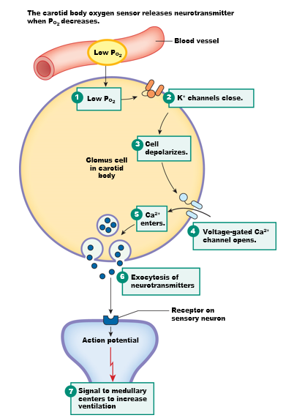

* WHAT’S THE THRESHOLD TO ACTIAVTE GLOMUS CELLS? HOW LOW SHOULD partial pressure of oxygen drop?
  + It has to drop ALL THE WAY FROM 100 to 60… WTF. A 40% drop in partial pressure of oxygen? WHAT A CRUMBY SENSOR. It’s almost as if Im almost dead to activate the DRG? Well.. remember dubsunsky—if it’s still here it’s been selected.
  + THIS IS BECAUSE THE GLOMUS CELL IS REALLY ONLY SECONDARY TO CONTROLLING VENTILIATION. IT IS A BACKUP SYSTEM.

THE PRIMARY WAY: IS IN THE MEDULLA OBLONGATA in the DRG

* The CHEMOsensor senses an increase in CO2 => causes CO2 to diffuse across the BB => in the cerebral spinal fluid => immediately converted into carbonic acid and proton and bicarbonate => activates the respiratory control sensor to some -unknown- receptor.
  + THE PRIMARY CONTROL OF VENTILIATION IS THROUGH THE **CENTRAL CHEMO-SENSOR, which detects CO2 levels, but not CO2 directly, and they found that out because they added CO2 alone was not doing anything…it was protons.** 
    - The protons diffuse poorly through the BBB because they have a charge. That’s why acidosis in blood doesn’t *necessarily (but it typically can (??)* cause your respiratory center to increase. It is really CO2 levels

DISEASE CONDITION [EXAM] **chronic obstructed pulmonary disease (COPD)**

* You have have a condition in which your pCO2 level is CHRONICALLY high. So your body adjusts and learns that that relatively high pCO2 is your new normal.
* Chronically elevated pCO2 levels cause your chemoreceptors to become less sensitive to CO2.
* Therefore, your only way to control CO2 levels is through your phepherial (2ndary) receptors.
  + The magic number is 60 pCO2, which his probably the number you have if someone suffers from **chronic obstructed pulmonary disease (COPD)**.
* Let’s imagine that someone walks into the emergency room, unconscious. The standard operation calls for incubation, so that we can at least not worry about this dude’s brain trauma affecting his respiratory control center that might stop his breathing.
  + But what if that person suffered from COPD? And you had no idea.
    - And if you bring oxygen levels back up, and therefore decrease CO2 levels, you actually STOP someone’s breathing because the 2ndary response turns off (the glomus cells), and might cause respiratory paralysis.

**CHALLENEGE TO THINK ABOUT**

* Think about ventiliation for a person who lives in Denver, clorado where the atm is not 760, but 628 mmHg. HOW DOES THIS AFFECT THE A VEOLOAR PARTIAL PRESSURE, and as a consequence affect the pressure gradient that forces oxygen diffusion.

In the final exam, calculate what is shown there, and

* Tell me and conjectures what happens at people at sea levels and people at high elevation.
  + There is not less oxygen in Denver, but rather a lower partial pressure.
    - SO… 628 x 21% = 131.99 mmHg, so lower partial pressure inside avelolar might cause a lower gradient and less oxygen diffusion.

## CHAPTER 19

19.1 Functions of the Kidneys

1. Regulation of extracellular fluid volume and blood pressure
   1. Regulation of volume also regulates blood pressure.
2. Regulation of osmolarity
   1. Regulating the concentration of electrolytes in the plasma.
   2. Recall osmolarity instead of concentrations. Because osmolarity takes into account the amount of solutes. For instance 1 mole of NaCl is equal to 2 equimoles.
3. Maintenance of ion balance
4. Homeostatic regulation of pH
5. Excretion of wastes
6. Production of hormones

19.2 Anatomy of the Urinary System

* Kidney’s are not in the adbonminal cavity because the abdominal cavity is contained within the peritoneal membrane. The kidney is not; it has its own mesentery. The two kidney beans are located closer to the back.
* Kidney’s are irrigated by renal arteries and renal veins.
* Sitting on top of the kidney, the name says it all, **adrenal glands**.
* In the macro-antomny, there is a tube coming down of the kidney is the **ureter**, NOT the urtha.
  + **Ureter** carries urine from the pelvis of the kidney to the bladder.
  + **The urethra** carries urine from the bladder to the outside.

**Kidneys**

* Most outer layeris the **cortex**.
* Then there’s the **medulla**, which converges into this hollow space known as the . . .
* **Pelvis, which** opens up to the ureter.
* 80% of filtration happens in the cortex because 80% of the **nephrons** are located there. (cortical nephrons)
* Inner medulla contains 20% of nephrons (justamedullary nephrons)
* Efferent and afferent.

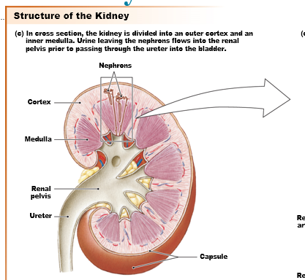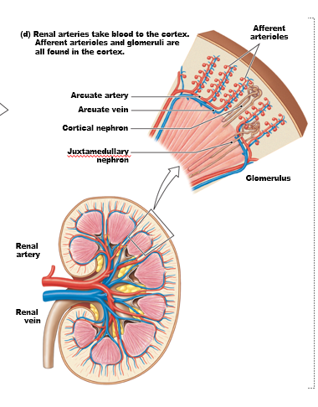

Tubular Elements of the Kidney

* **The collecting duct** is where all kidney’s end at.
* **“filitration, reabsorption, secrection, and excrection**”
  + and the excreted fluid ends up in the collecting duct.

Figure 19.1(g-h) Anatomy summary

* **The loop of Henley** is actually twisted,.
* Capillaries converge to form the **glomerulus**.
* The baseball glove around the glomerulus is the **bowman’s capsule**.
* *Once you cross the endothelial wall of the glomerulus, you are not longer inside the body, but outside of the body.*
* Then, the convoluted tubule is called the **proximal convoluted tubule**, which then…
* Extends itself downward and upward known as the **loop of Henley**.
* Back upward, the distal tubule is called the **distal** **convoluted** **tubule** because it’s further away because when *stretched* out, filitrate is actually further away, even though in normal anatomic structure it appears closer.
* Finally, it ends at the **collecting** **duct**.

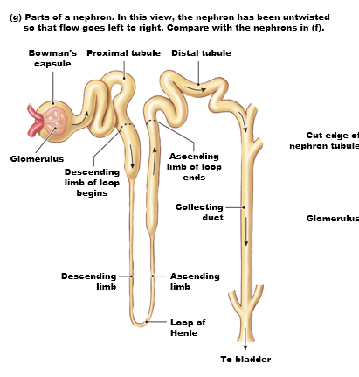

19.2 Overview of Kidney function

- **Kidneys filter, reabsorb, and secrete**

* If we measure the amount of blood the passes through the kidney it’ about 180L blood.
  + 26-30% of blood supply is at the kidney.
* However, out of the 180L, we only lose ~~0.5L~~ of fluid per day. --
  + (Does this make you think of a kidney as a very conservative filtration system?
* If you measure the concentration of the filtrate right at the other side of the glomerulus, it’s about the same as the plasma (298mOsm), but this osmolarity changes as it passes through the loop, and tubules.
* Plasma enters the tubule through the glomerulus.
  + what’s in the filtrate? Water, glucose, NO proteins…
    - everything but cells and proteins, though some small peptides can cross, but will be reabsorbed
  + **about 99% of filtrate is reabsorbed.**
  + Some things that was not filitered for whatever reason, is **secreted**.
    - **Secretion is ACTIVE TRANSPORT of stuff out of the blood supply in the EFFERENT arteriole, after the glomerulus.**
  + As said earlier, 99% of filitrate is reabsorbed.
    - Most reabsorption happens in the loops of helenly and distal tubule,
      * (details on Wednesday)
  + In addition some secrection oand reabsorption happens in the distal convoluted tube,
  + And really in the collecting duct: thing only thing that exchanges is WATER and UREA, nothing else.
* as soon as plasma crosses the glomerulus into the tubule, it’s not longer plasma, but filtrate, and the composition of the filtrate is going to change as it flows down and upwards.
* When filtrate arrives at the collecting ducts, it’s not called filtrate anymore, but urea because most if it water and urea.
* These four mechanisms allow for control of electrocylte concentration, control of blood volume and pressure, **control of pH**, and hormonal control from the kidney and waste disposal. The kidney’s do NOT PRODUCE waste, but secrete it.
  + **MOST WASTE IS PRODUCED IN THE LIVER, where most protein are regarded, where ammonia is converted to something less toxic.**
  + Where all that hemoglobin that was degraded through blood function and turn it into **bilibrin**, which is what turns your poop brown (SEEN IN A WEEK AND A HALF)

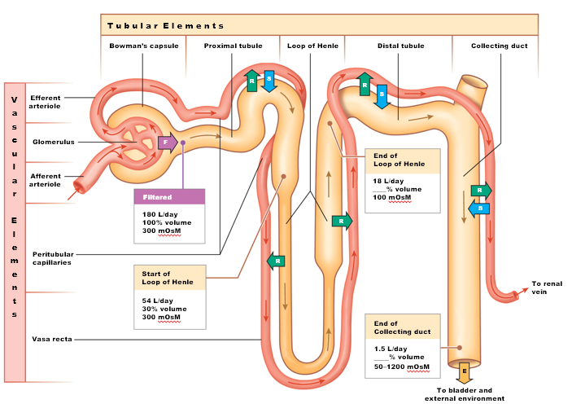

**Figure 19.3 Solute movement through the nephron**

* **ONCE AGAIN, ALMOST EVERYTHING THAT IS FILITERED IS REABSORPED. AND THAT’S BECAUSE OF CONCENTRATION GRADIENTS that are being created as the filtrate passes.**
* The walls of the **endothelial walls in the capillary walls in the glomerulus are FENESTRATED.**
  + **FENESTRATED = transcytosis is happening at such a fast rate, there are physical windows that are over 100 nm wide, which is huge.**

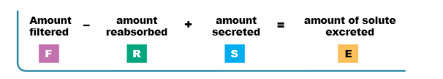

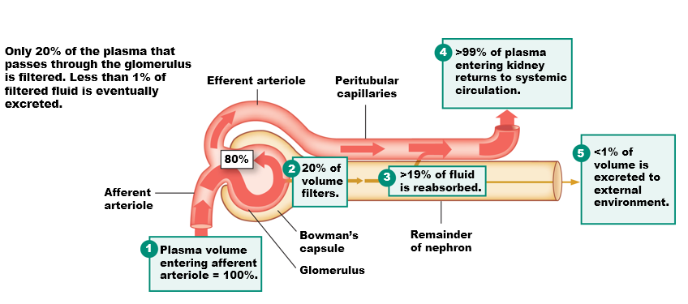

* **HOW IS THE POROUSITY of the glomerulus controlled?**
  + **The function of podocytes that hug the blood vessels and put their fingers on the fenestration. These fingers are foot processes.** 
    - **So what controls the permeability of the glomerulus is the activity of the podocytes.**

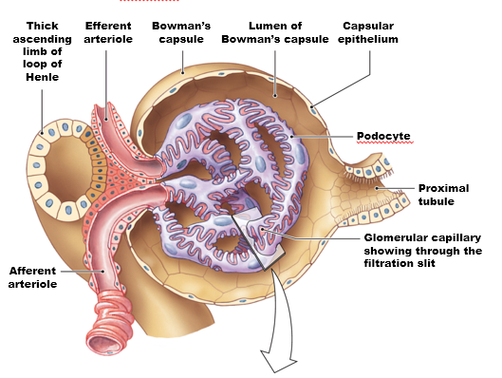

**Figure 19.5(c-d) The renal corpuscle**

* **Notice the lumen of the bowman capsule.**
* In the middle is a cell known as the **mesangial cell**. These cells have the ability to contract in response to certain hormones. Contraction of mesengials “somehow close the glomerulus.” So contraction nof mesangial cells restricts filitration.

TWO WAYS TO REGULATE:

1. By action of podocyte
2. Function of mesangial cells.

If you zoom in even more, at the iflitration slit, talking about the extracellular matrix that forms a loose slit for proteins to pass through filitration (lol no?) and then a photo with a podocyte closing the filitration slit… what?

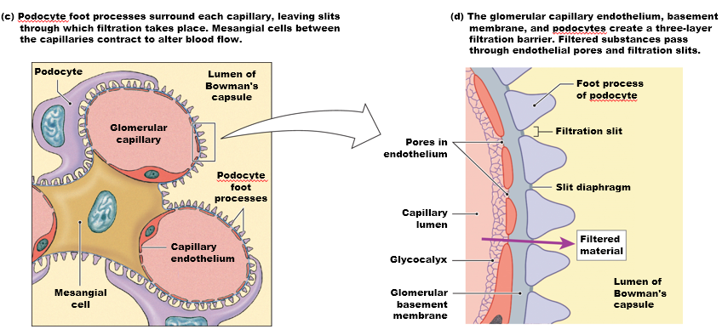

**Capillary Pressure Causes Filtration**

* **What drives movement across the filter is really pressure gradients.**
* Hydrostatic and oncotic…except you also need to think about TWO types of hydrostatic pressures.
* HYDROSTATIC PRESSURE(S)
  + 1) pressure exerted by blood = 55 mmHg (which is a bit higher than in the capillaries, 35 mmhg)
    - But the magnitude of the hydrostatic can be regulated as well … . . .
  + 2) the other side of the glomerulus has liquid as well! FILITRATE!. Filtirate exerts hydrostatic pressure as well, back against the glomerulus known as **FLUID** **PRESSURE** (to avoid confusion)
  + HOWEVER, recall plasma that is exerting the 55 mmHg of hydrostatic pressure also has proteins. Proteins that exert oncotic pressure that favor **ABSORPTION**, which is constant, constant at 15 mmHg.
    - Therefore**, doing the calculations 55 mmHg of hydrostatic (plasma) – 15 mmHg oncotic (plasma) – 35 mmHg fluid pressure (filitrate) = 10 mmHg** NET FILITRATION!.
      * Fluid and oncotic favor absorption
      * Hydrostatic favor filitration.
  + **Net pressure = PH – π – Pfluid = 10 mm Hg into Bowman’s capsule**

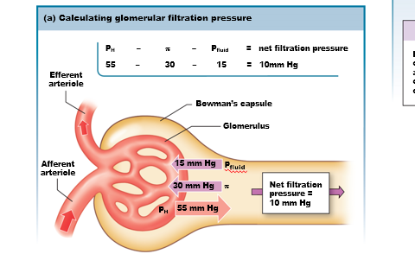

**THE AFOREMENTIONED** pressures is just talking about at the glomerulus.

As you move out, what really changes is hydrostatic pressure, and NOT oncotic pressure; which remains the same because proteins do not leak into the filtirate.

* AS WE learned back in the day, hydrostatic pressure at the ARTERIAL END IS HIGHER than at the VENOUS end BECAUSE
  + LOSS OF ELECTROLYTES
  + FRICTION that causes a drop in hydrostatic pressure.
* So you can imagine that the net pressure of 10mmHg favoring FILITRATION may end up turning NEGATIVE as you move AWAY from the glomerulus.
  + AND THAT’S HOW WE HAVE **REABSORPTION** !!!!!

Capillary Pressure Causes Filtration (part 2: qualification of filitration rate) **AND** Figure 19.6(c-e) Glomerular Filtration Rate

* If we quantify the fiitration rate, glomerular filitration rate (GFR), which is the X amount per unit of time.
* Glucose is going to filiter through the glomeruli in a different rate than penicillin or cocaine BECAUSe permability is selective, and concentrations of these determine how fast one is filitered than another.
* So when you consider the plasma concentration of a certain substance, and how quickly it appears in the urine, you can calculate the GFR.
  + Filtration can be controlled by a number of perimeters.
    - ~~If blood pressure is HIGHER at the ENTRANCE (afferent arteriole) than you INCREASE the hydrostatic pressure at the glomerulus, which favors an increase in filitration, in GFR.~~
    - ~~BUT, if you increase the pressure in the efferent arteriole, you’re actually preventing blood flow out of the glomerulus. If you narrow the exit point of the glomerlysis, then you’re increasing the hydrostatic pressure of the glmoeruylsus as well.~~
    - ~~So VASODILATION of the EFFERENT~~
  + 34:37
* BASICALLY, vasoCONSTRICTION of the AFFERENT arteriole will DECREASE GFR because less blood is flowing there.
* BASICALLY, vasoCONSTRICTION of the EFFERENT arteriole will INCREASE GFT because hydrostatic pressure increases due to the backflow or “stoppage” of blood.
* BASICALLY, vasoDILIATION of the AFFERENT arteriole will INCREASE GFR because more blood flow.
* BASICALLY vasoDILATION of the EFFERENT will DECREASE GFR because of decreased hydrostatic pressure.

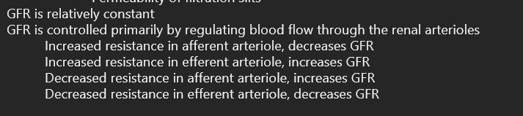

CAPILLARY PRESSURE IS CONSTANT **[EXAM EXAM EXAM]**

* Increase or decreased in MAP will NOT affect GFR.
  + This is because GFR is *AUTOREGULATED*, and the glomerulus can control GFR in spite of changes in blood pressure.
* Notice that GFR is stable at **180L/day or 125mL plasma/minute.**
  + **So between 80 mmHg to 180 will NOT cause an increase in GFR**
  + **Below or above will change, this underlies the ability of autoregulation; to ajust the thickness and narrowness of the efferent and afferent capillaries in response to MAP.**

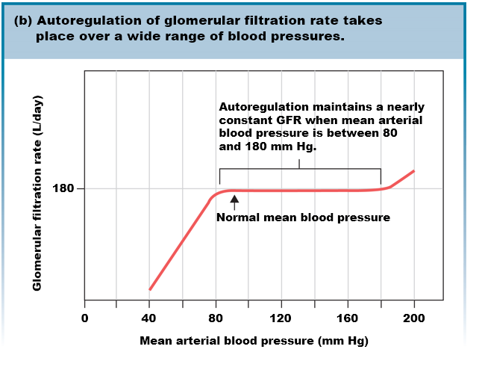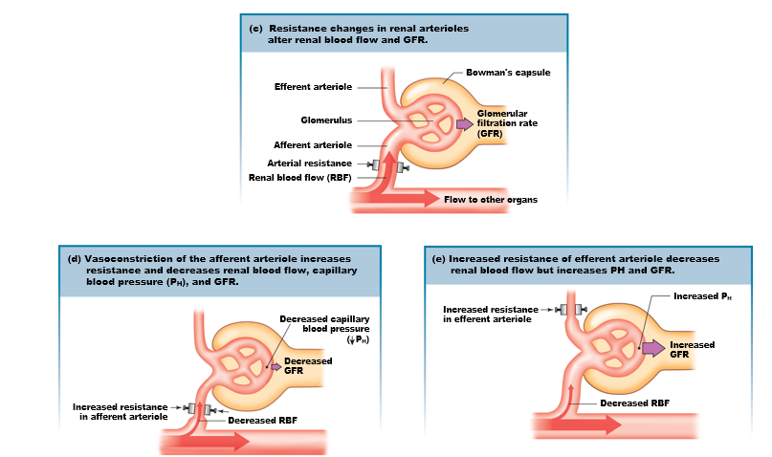

GFR Is Subject to Autoregulation: WHAT ARE THE FACTORS?

* Glomerulus has smooth muscles and has **myogenic responses**. Smooth muscle can control the change.
  + Increased blood pressure => STRETCH-sensitive ion Ca2+ channels open and deplliarze the cell => contraction => constriction increases resistance of flow, which decreases filitration pressure back to normal.
  + Uhhh if blood pressure decreases, arterioles become maximally dilitated. However, vasodiliation is not as effective I mainitaning GFT as vasoconstriction because arterioels are already normally relaxed. GFR decreases and blood volume is conserved.
    - … the decrease in blood pressure is adaptive in a sense because a decrease in GFR when under 80 mmHg will conserve blood volume.
* The **intersection between the distal tubule and the glomersus is called the JUXTAGLMOERULAR APPARATUS.** 
  + It’s a region formed by cells that have paracrine secrection that respond to
    - 1) PRESSURE
    - 2) composition of filitrate
  + The cells present here are TWO types:
    - 1) MACULADENSA
    - 2) GRANULAR CELLS
* If GFR is increased => increased NaCl delivery => Macula densa sends paracrine signals that cause afferent arterioles to constrict, increasing resistance and thereby decreasing GFR.

HORMONE SIGNALING:

* Angiotension II (VASOCONSTRICTOR
  + Renin => angiotensin
* Prostaglandin (VASODILIATOR)
* 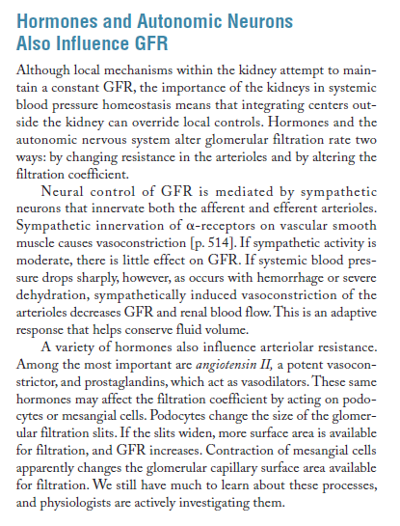

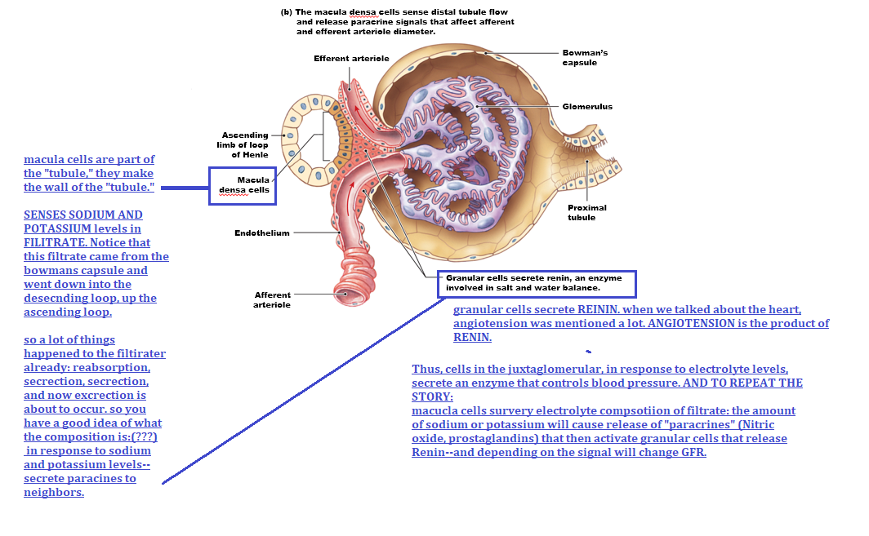

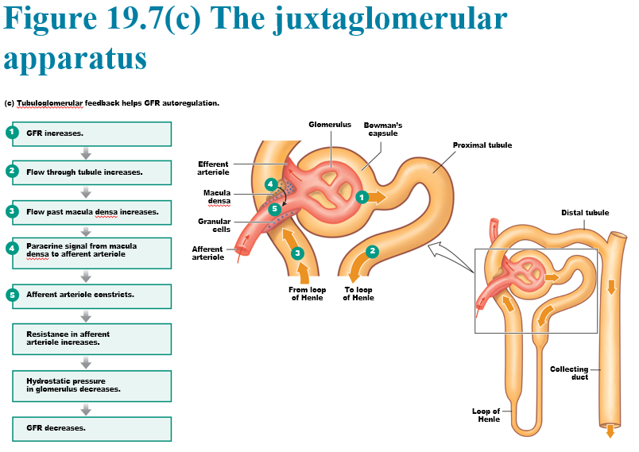

## 19.5 Reabsorption

* At the glomerulus, the filitrate begins as roughly the same OsM, 300.
* But 99% of what is filitrated is reabsorbed.
* **Almost ALL of the glucose filtered is reabsorbed.**
* (unless you have diabetes, then it gets filtered and goes into the urine).
* Thus, reabsorption is following concentration gradients, like in this case.
* HOWERVER, some sometimes reabsorption is taking things that are higher concentration in the plasma, which requires energy.
  + TRANSEPITHETIAL AND PARACELLULAR TRANSPORT.
* When it comes to reabsorption—the leading electrolyte is sodium.
  + We use sodium in co-transport and sodium is reabsorped alone (recall the sodium-glucose co-transporter.
* **WATER FOLLOWS electrolyte flow: so osmosis is the next step once sodium crosses back into the blood supply.** 
  + But how does sodium get into the cell? SODIUM TRANSPORTERS. (why do we need em? **Cause sodium is higher in the ECF)**
* **Sodium moves in a transcellular wave, and if you create this sodium gradient, anions will follow.**
  + **Anions can travel paracellular or transcellular because the ECF has more + charges due to more sodium**
    - **Water follows anion. WATER can travel** paracellular and transcellularly, but for it to travel transcellularly, you need a channel known as **aquaporins**.
  + Other things follow as well, such as urea.
* Sodium is higher in the ECF.

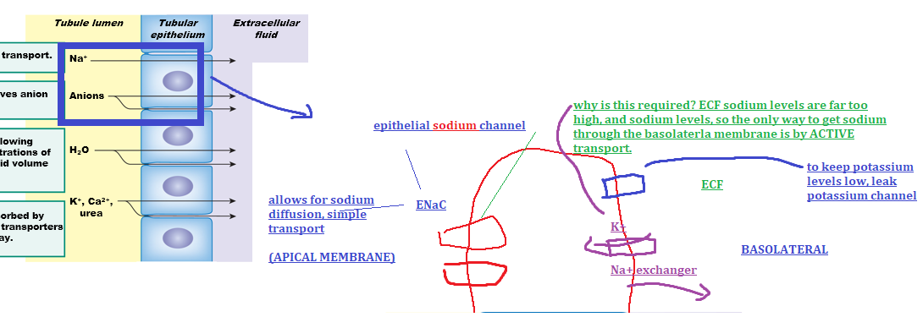

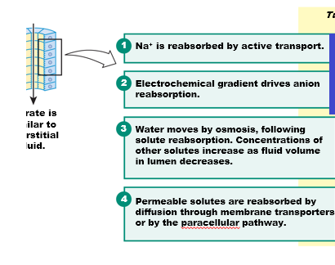

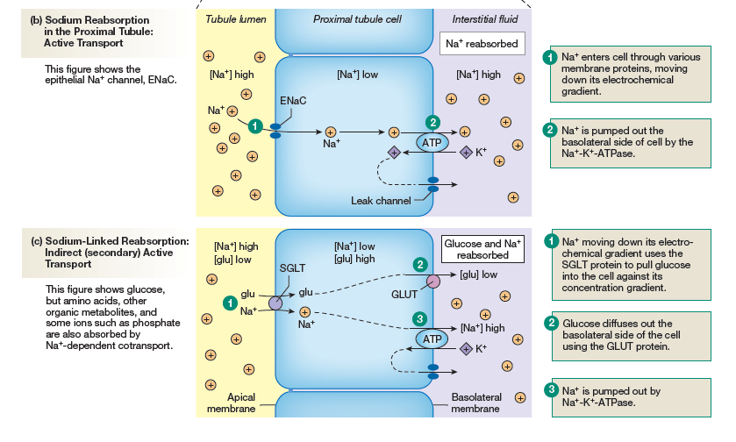

**Reabsorption May Be Active or Passive**

* In the same membrane above, there is a SGLT **(sodium-glucose symporter).** 
  + if you’re poor and it’s the summer, drink some sugar with salt, because the salt is needed to absorb the sugar.
* This has the same “mechanism” to speak as above, not really.
  + 1. Presence of SGLT transports glucose inside the cell because glucose levels are higher in the cell than in the tubule lumen.
  + 2. Glucose can easily diffuse out of the cell using a GLUT protein (just a channel), because GLUT is low in the interstitial fluid.(or in the blood…?)
  + 3. Sodium is transported out of the cell in the basolateral membrane, and then the leak channel removes the K+

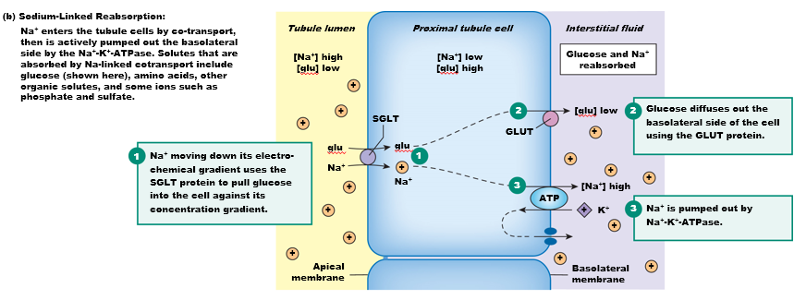

* **THIS SODIUM POTASSIUM ATPase (PUMP) and leak channel is VERY typical in basolateral membranes.**
* BOTH THE ABOVE MECHANSIMS ARE IN THE PROXIMAL TUBULE!!!

**What would be the good in expressing an endothelial sodium channel in the basolateral membrane?**

* **This will cause sodium to flow INWARDS.**
* **This makes no sense in the proximal tubule, where reabsorption is wanted.**
* **BUT, it does make sense in the DISTAL tubule, where the intentions are to EXCRECT SODIUM, to get RID of sodium in the blood.**

**Renal Transport Can Reach Saturation**

* The amount of transport depends on
  + The concentration of the molecule
  + AND THE AMOUNT OF TRANSPORTERS (this is similar to enzyme kinetics)
* If all the transporters are full, **then SATURATION: maximum rate of transport that occurs when all carriers are occupied by (are saturated with) substrate**
  + **(thus increasing concentrations**, will not increase transport rate).
* This concept is important because of glucose. Glucose transport is 90mL glu/100mL of blood, and spikes to 150 mL/ 100mL blood. And above 150, no there will be no change in glucose transport.
* Now, without saturation, as you can see by the graph, filitration and concentration rates are directly proportional.
* And **if saturation is** reached, then whatever substance it is, any extra pass the saturation point will be **EXCRETED, and that is how glucose ends up in the urine**.
  + So **glucose that is not filtered at the proximal tubule, will make it into the urine ☹**
  + **Tl;dr: if luminal concentration is higher than plasma concentration, you’re saturating you’re reabsorption system and it’ll end up in pee, excrection.** 
    - **Thus, renal threshold** of a substance is the plasma concentration of that substance in which reabsorption pleateus and excrection starts.

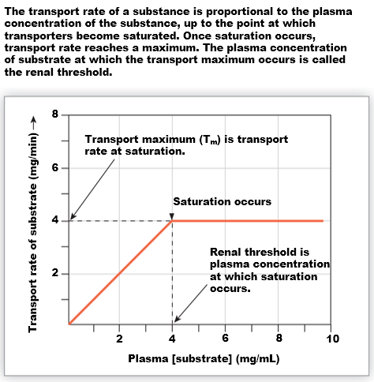

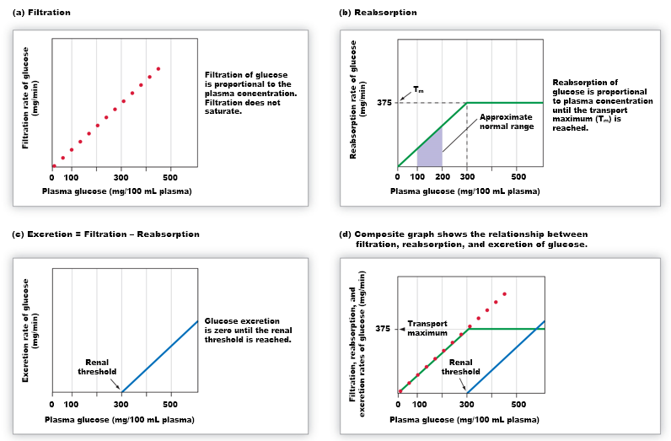

**Figure 19.11 Reabsorption in peritubular capillaries WHY DOES IT OCCUR?**

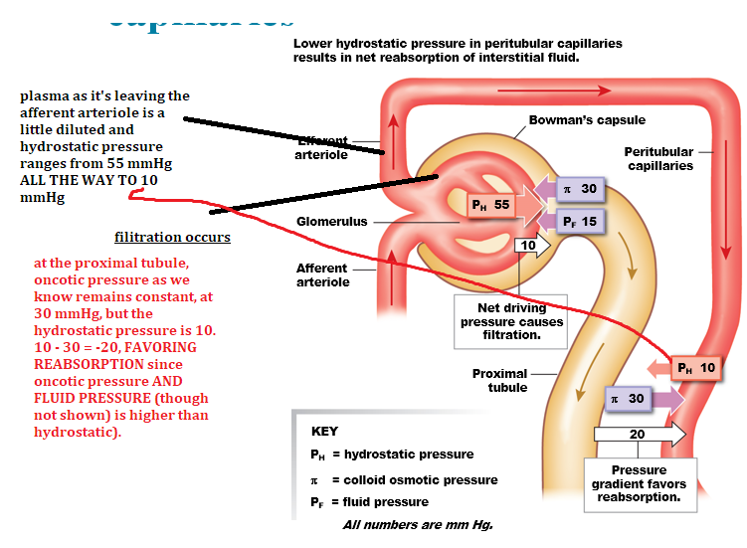

## 19.6 Secretion: SECRECTION – MUST BE ACTIVE TRANSPORT.

**- regulates the hmoestatsis of potassium, and protons, and organic anions (OA-)**

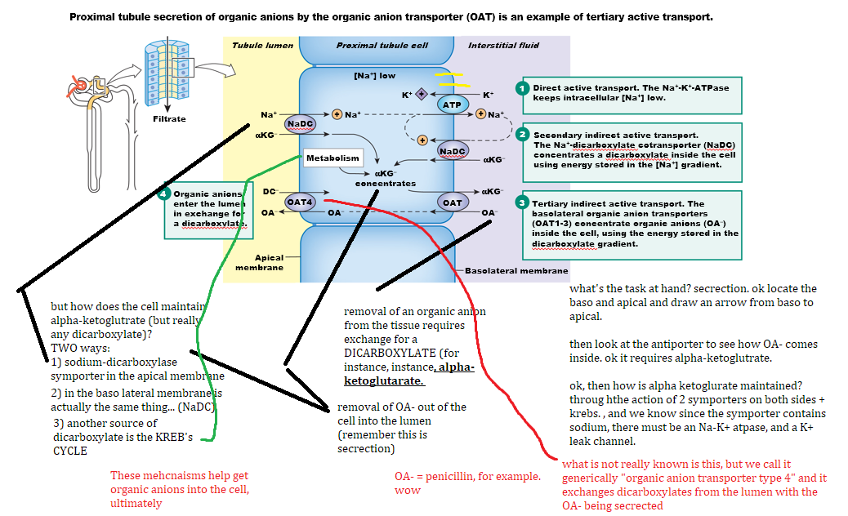

## 19.7 Excretion

* **Excretion = filtration – reabsorption + secretion**
  + Also known as renal handling.
    - Another way to measure renal handling
* **Clearance** is a non-invasive way to measure GFR.
  + **GFR** should be the rate of which X substance of the plasma passes through the filter, but that requires you to know how much of that substance is in the plasma, and that’s invasive—and then that you collect urine and then find out how much substance is in the urine.
  + **The clearance of a substance is** . . 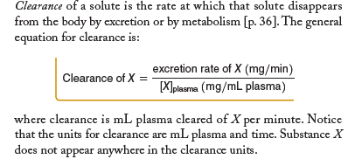

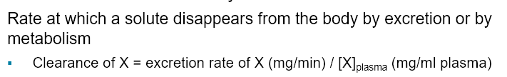**-** no need to memorize, think logically.

- plasma = removal ===so the removal is going to be the excretion rate and what proportion of that is compared to what is left behind in the plasma-----**so it’s not how much that has been excreted, but how much that has been removed from the plasma.**

* There’s a substance called **inulin**, that is not reabsorb at all.
  + So if you collect urine over time, and you measure the concentration of inulin in that volume of urine per time, you calculated the clearance of inulin.
* So if you quantify inulin in the urine per unit of time (24 hours) for the amount urine that was excrected, you calculate the clearance.
  + THE CLEARANCE = THE SAME AS GFR, for substances that’s not reabsorbed.
* But we’re not going to be injecting people with inulin.

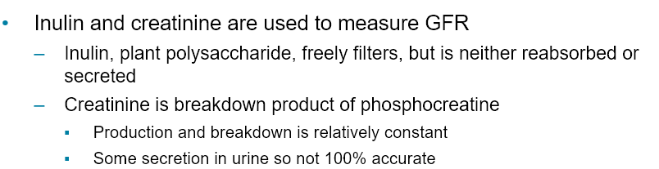

* Asdd – **creatinine** is constant—something about it being a saturated amount.

Asdasd

* SO ON WEDNESDAY, HE’ll BRING A PROBLEM TO PLAY WITH.
  + FIRST, CALCULATE GFR BASED ON CREATININE.
  + THEN, USE THAT TO SAY… so how is the kidney handling glucose?
    - Multiple plasma concentration of glucose X GFT = filter load of X

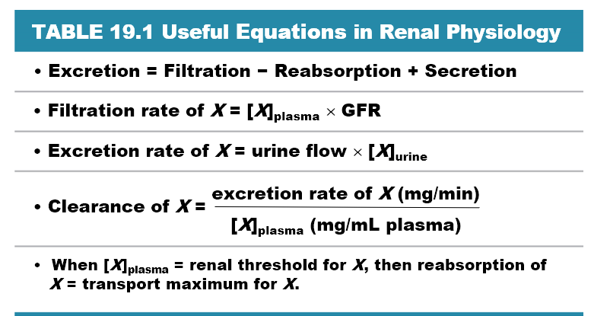

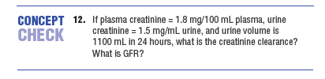

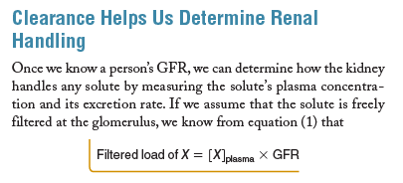

HONESTLY REREAD PAGE 635. AND YOUTUBE IT.

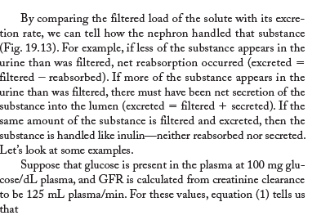

* We do **not reabsorb penicillin, and we secrete it on top of what was filtered------ so there’s a higher net of excretion.** 
  + This was an issue with penicillin in world war. We keep nothing in the blood supply, so we be collecting urine and reapplying urine as a source of penicillin.

[AK Lecture]

* Renal cleararance tells us how much volume of blood plasma is completely cleared of that substance over some time period by our kidneys.
  + The units of renal clearance = (mL/min)
* The rate at which blood flows into the nephron for normal kidneys is about 625mL of blood plasma through the afferent arterioles and into the glomerulus every single minute. (625mL blood/min).
* About 20% of that blood plasma that enters the glomerulus becomes filiter, therefore 625 mL x 20% = 125mL blood filtered/minute.
  + THIS IS THE NORMAL GLOMERULAR FILITRATION RATE (GFR) = 125mL/minute (or about 180L/day)
* As such, only about 500mL of blood (20% less) travels through the efferent tubule, which lowers hydrostatic pressure as well…
* Therefore, there are really only two ways things can end up in our filitrate—
  + Firstly, if it’s filtered and NOT reabsorped
  + Secondly, if it’s secreted when it travels through our efferent arterioles and ends up in our peritubular capillaries.
* Different substances have different values for the renal clearance. So let’s begin with some hypothetical substance, X, and what happens as it moves through our nephron.
  + CASE1: freely filtered, not absorbed, not selected.
    - Freely filtered means that it’ll flow freely when it enters the bowsman capsule. This means that the **concentration of X substance is the same** inside and outside of the bowman’s capsule.
    - If none is reabsorbed in the tubules and none is secreted in the peritubular capillaries, then that means that **the renal clearance simply equal to the filtration rate (GFR).** 
      * one such example is **inulin**.
  + CASE2: freely filtered, fully reabsorbed, not secreted.
    - 125mL/min is filtered, but since all is reabsorbed, then renal clearance will = 0 mL/min.
      * EXAMPLES: glucose and amino acids.
        + Can be easily filtered, but they are reabsorbed
  + CASE3: freely filtered, not reabsorbed, fully filtered
    - 125mL/min is filtered, and because it’s fully secrected, then you can also add the volume of the efferent arteriole blood volume, which means
      * 125 + 500 = 625 mL/blood is clearance PER minute.
  + CASE4: freely filtered, slightly reabsorbed, not secreted.
    - 125mL/blood is filtered, but a small amount is reabsorbed back into the peritubular capillaries, which means that renal clearance will be less than 125mL.
      * Example: urea, is filtered, but about 60mL/min is reabsorbed. Therefore 125 – 60 = 65mL/minute that is cleared in the blood per minute.
  + CASE5: freely filtered, not reabsorbed, slightly scrected.
    - This value will be between 125mL/min and 625ml/min cleared, higher than the GFR, but literally cannot be higher than the amount of blood flow.

[VIDEO 2] = Calculating Clearance – Example Calculations

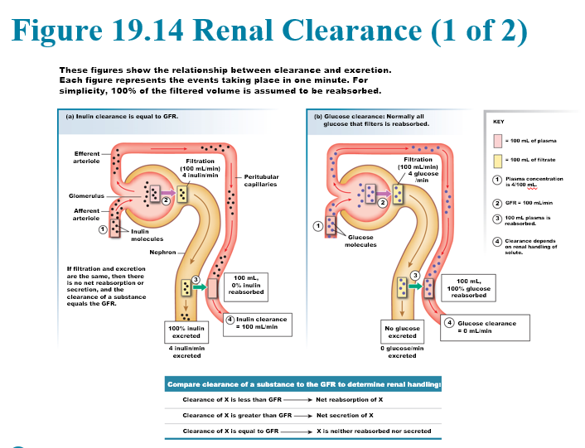

## Micturition: urination

* the internal sphincter is a continuation of the bladder and consists of smooth muscles.
  + Thus, it is controlled by parasympathetic fibers. Normal tone keeps it contracted.
* The **external sphincter** is a ring of skeletal muscle controlled by somatic motor neurons (think ACh).
  + Tonic stimulation from the CNS maintains contraction except during urination.
* Micturition is a spinal reflex that is subject to both conscious and unconscious control from higher brain centers. As the bladder fillers, the walls expand, stretch sensors send signals via sensory neurons to the spinal cord.
  + This information is transferred to **TWO** sets of neurons.
    - 1. The parasympathetic neuron leading to smooth muscle => contraction
    - 2. Somatic motor neuron leading to inhibition of external shpicters.

## 

# Chapter 20: Fluid and Electrolyte Balance

* in terms of fluid and electrolyte balance, there’s several ways of water regulation
* Body uses several routes for excreting ions and water
  + **Primary route is kidney**
  + Some water and ions in feces and sweat
  + **Lungs lo**se water and bicarbonate (via CO2)

Figure 20.1 Integrated responses to changes in blood volume and pressure

* Sodium makes you thirsty, and if you think that blood volume decrease causes an increase in blood osmolarity, which means increased concentration of sodium now why it’s a hemostatic mechanism
* In the opposite example, with increased blood volume and blood pressure
  + We known that cardiovascular response will cause decreased CO and vasodilation.
  + Now add the kidneys, kidney’s remove salt and H2O to counteract that high increase in blood pressure.
    - Recall that the kidney Is extremely conservative, but we lose about 2.5L of liquids per day.

20.2 Water Balance

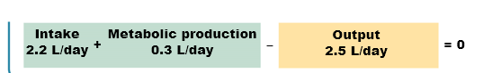

* mass action is favoring homeostatic, water intake = water loss.

Figure 20.3 The kidneys conserve volume

* when we talk about kidney’s control volume, we have to think that there’s an amount of water that remains constant in our body. There’s a threshold at which excess water can be removed through the kidney function, and what controls this is **autoregulation of glomerular filtration rates**.
* Kidney’s cannot reverse water loss, they can only CONSERVE water loss.
  + So if you body water volume, ICF, ECF, plasma circulation, interstitial fluid, drops below a certain point, there’s nothing the kidney can do. This is because volume drops too low. **GFR will stop**. You lose the kidney’ ability to regulate pressure.

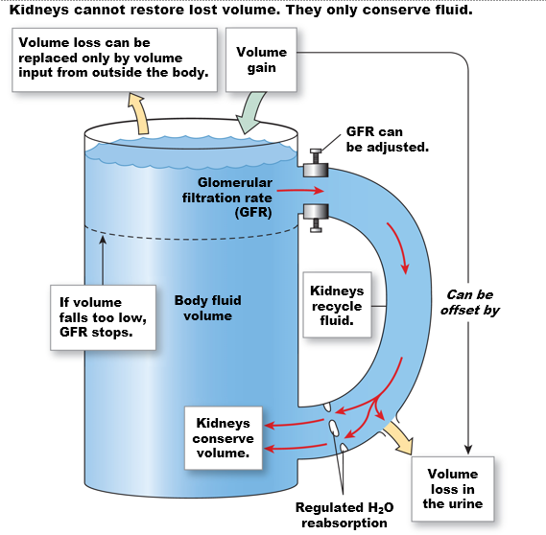

**The Renal Medulla Creates Concentrated Urine**

* Secrection, reabsorption, and excrection happen in the MEDULLA, not the cortex.
* And you can see that purple gradient represents that gradient that is more diluted at the top, and lower as we dig deep into the pelvis
  + This is possible because filitrate coming down the **descending loop of heleney** is losing water, which means the volume inside the filtrate is decreasing, without the loss of electrolytes (solute), so that **causes a concentration of the filtrate.** 
    - **Water loss from the filtrate** concentrates all the way down to 1200 mOsM, which is equimolar with the ECF because…
    - now at the ASCENDING loop of heleny, there is no longer water loss or reabsorption, but we are dumping electrolytes into the currents into the medulla.
* The PURPLE region of the distal tubule and the cortical part of the collecting duct is marked like that BECAUSE WATER REABSORPTION DEPENDS SOLEY ON THE PRESENCE OF ANTIDIEURTIC HORMONES**. So in principle these two regions are completely immperable to water**.
* So the concentration form urine can vary from 50-1200 mOsM, which depends on the presence of ADH.

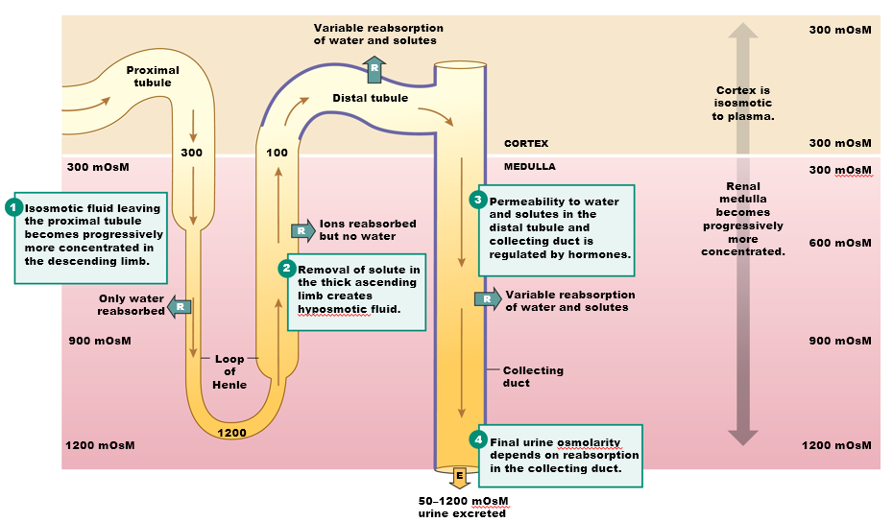

Vasopressin Controls Water Reabsorption  
- The nephron has blood vessels running in parallel, in parallel with the ascending, descending loops of heleny and collecting duct. These arterials go STRAIGHT alone side, which is why they’re called **vasarectal** (straight blood vessels).

* These blood vessels flow in OPPOSITE direction to the direction of the tubule, known as the **countercurrent** **current** **flow**.
  + The purpose of this is to transfer osmolarity.
    - Notice that the filitrate is most dilute as its going down, in the opposite direction of blood plasma, which is the most concentrated on the bottom, and gets most diluted as it goes upwards
      * AND THIS IS ONLY possible because water that is loss by the tubules is being **REABSORBED** by the blood vessel.
        + So one is losing water, becoming more concentration
        + And one is gaining water, becoming more dilute (blood vessels)
        + **THIS IS ONLY POSSIBLE BECAUSE THE DESCENDING LOOP OF HENELY AND THE COLLECTING DUCTS (WITH THE CAVEAT OF PRESENCE OF ADH), --- in the loop of heleny you ALWAYS have water reabsorption.**
      * ~~You can imagine that blood vessels here at this stage is more permeable to water~~
      * ~~Water is MORE permable at the top of the descending loop than at the bottom~~
* Countercurrent flow: osmotic transfer between the blood circulation and the tubules.

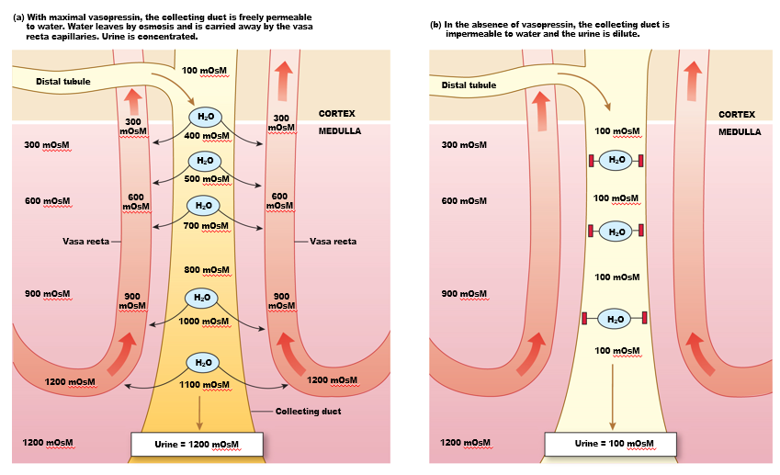

Figure 20.5(c) Vasopressin makes the collecting duct epithelium permeable to water

* **ANTIDIEURTIC** means DO NOT urinate. It is a hormone delivered in the blood supply.
  + **The** ~~superior pituitary~~ secretes ADH. If it prevents you from urinating, then it’s increasing blood volume, which is increasing blood pressure. That is also why ADH is called **vasopressin** (blood vessel—pressure).
  + (hormone made by the hypothalamus in the brain and stored in the posterior pituitary gland. )
* MESSAGES have a target audience. Whatever cell expresses the receptor for ADH—and in this case are in the **lining of the distal tubule** and **lining of the collecting duct**.

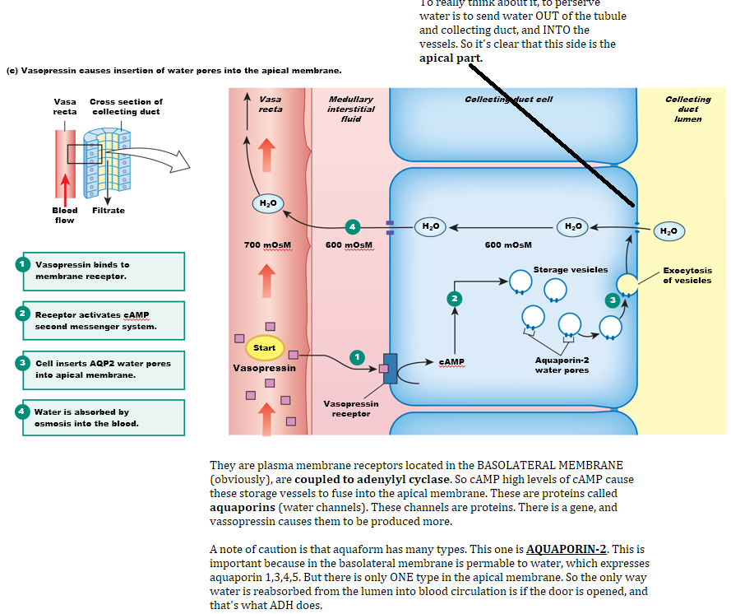

Figure 20.6(a) Vasopressin

* There are THREE different stimuli that cause the release of the 9 amino-peptide called VASOPRESSIN, that is lollipop.
  + 1. The bonafide signal for ADH production is a DROP IN BLOOD PRESSURE (or low blood volume) => talks to aortic baroreceptors (and coratid) => talks to sensory neurons in hypothalamus => which innverate the hypothalamic neurons that synthesize vasopression (which is the source of production of ADH) => causes these neurons to DUMP ADH into the posterior pituitary and then into the blood circulation. CLASSIC.
    - Pressure => activates cardiovascular control => sends excitatory signals to hypothalamus => pituitary => dumps ADH. CLASSIC.
  + If you have a drop in blood pressure, that’s potentially because you have a drop in blood volume. . . 2. So that decrease in blood volume are sensed by **stretch receptors, like neurons that are attached to the walls of the atria (like stretch receptors in the bladder**, and these neurons will signal to the hypothalamus for ADH secretion.
    - ---both the first and 2nd are connected, decrease in blood volume, will likely decrease blood pressure, but what’s **novel here is that now we know there are stretch sensors in the heart.**
      * A drop in stretch in the artia will cause ADH secrecting.
  + **3rd trigger** for ADH: OSMOLARITY!
    - There’s no teleological reasoning behind this.
    - The neuroserectory cells in the posterior pituitary will CHANGE their “swellingness” based on osmolarity. Does that make sense? Asdjlasdjkl
    - Osmolarity will cause cells to shrivel or swell.
      * We’ve already learned that like a bunch of other cells, like glomus cells, in response to stretch . . .
    - **Stretching of cells will cause closure of potassium channels, cell depolarizes, opening of VG-Ca2+ channels, Ca2+ influx causes exocytosis => exocytosis of ADH**
    - AND THE MAGIC **NUMBER IS 280 mOsM.**
      * ~~So, we already have some base level of ADH secretion because our ballpark osmolarity is really 300 mOsM, but if we have an even greater increase in mOsM, we stop ADH secrection. WHY?~~
        + ~~Increased in mOsM in blood means increased volume of blood. (?????) What does osmolarity have to do with blood volume? IM SO CONFUSED~~
      * **If you decrease osmlarity in the ECF, then your cells will lose water in the ECF??** 
        + **Stretch receptors in the atria will talk to the hypothalamic center….**
* **Dude is straight up just wrong about the 3rd reason.** 
  + **Depolarization occurs when cells SHRINK.** 
    - “**A loss of water volume in the body increases blood osmolarity and decreases blood pressure. “**
      * Increase in osmolarity in the blood will cause cells to SHRINK causing depolarization, causing a release of ADH, which causes water reabsorption, and thus return back to normal.
        + THIS ANSWER MAKES A WHOLE LOT MORE SENSE. AND THE GRAPH SHOWS THAT.

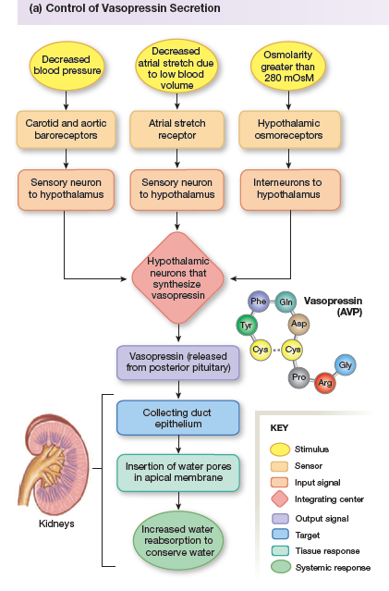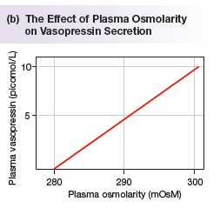

**The Loop of Henle Is a Countercurrent Multiplier**

* Think about both sodium and water.
* Water comes out of the descending loop of heneley, and does NOT come out of the ascending loop.
* In the ascending, the bulk of reabsorption is happening—sodium coming out of the lumen of the ascending loop. So **this** **justifies how we concentrate the medulla (the ECF in the medulla)** 
  + And you notice that in the descending in earlier slides, that mOsM increases as it goe down, but then it increases again as it goes up, and this is Not because water is coming back in, but rather solute is leaving without the loss of water.
* If you try to understand how these solutes are crossing the endothelial barrier in the ascending loop Henley. Here is the MAGNTIFICATION OF THAT STORY
  + In the APICAL MEMBRANE, (yellow is showing the lumen), and we’re talking about reabsorption: there’s this symporter that’s the most common: **NKCC transporter**; this is incredibly important because it handles sodium, potassium AND chloride in the apical membrane, and obviously water CANNOT pass through the apical membrane. And it will NEVER pass because ADH does NOT have a receptor in the ascending loop of Henley (recall ADH is only in the distal tubule and the collecting duct).
  + On the BASOLATERAL membrane, there’s a classical sodium-potassium pump, and you already know that there’s potassium leak channels, if Na-K ATPase exists… and in addition, there’s a **symporter for potassium and chloride**.
    - **[EXAM] there’s definitely going to be question to summarize the mechanism of reabsorption in different parts of the nephron**.
  + **THE EXPRESSION OF THESE POTASSIUM CHANNELS AND THE PUMP IS REGULATED BY ANOTHER HORMONE—talked about later.**
  + **BUT FROM THIS WE GOT HOW REABSORPTION IS REGULATED.**
* **So do not use teleological explanation**

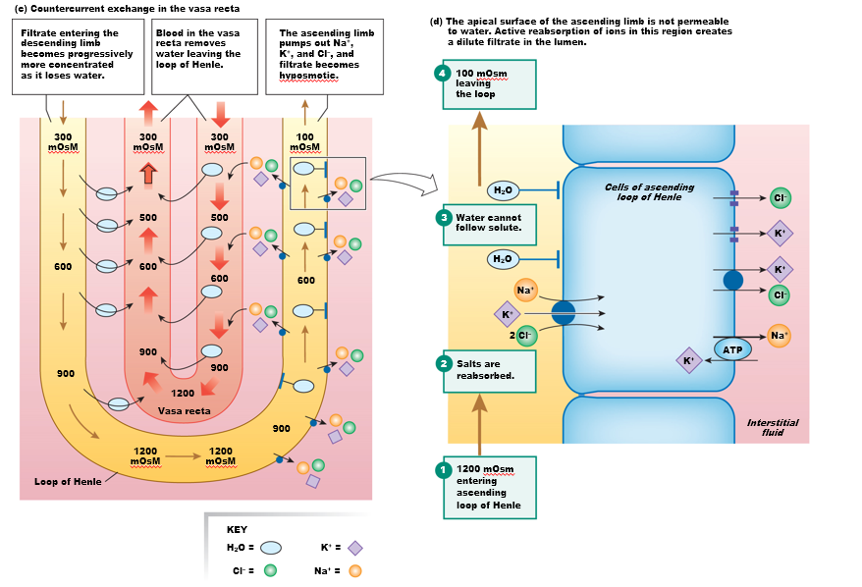

**Figure 20.8 Homeostatic responses to salt ingestion**

* We ingest about 155 mmol oof sodium in the American diet.
* As such, what’s the ECF sodium concentration in the ECF?
  + The cheat sheet will tell us 140.
* Thus, our diet is hyperTONIC in terms of sodium.
* So sodium ingestion will normally cause an increase in the osmolarity of the plasma. Increase in osmolarity as we know, ACTIVATES vasopressin secretion. THERE WE GO. HE SAID IT CORRECTLY THIS TIME. NICE.
  + And we already know what ADH secretion does—water conservation by the kidneys.
  + **This water conservation is going to cause an increase in the ECF volume. Because there’s nothing preventing water from moving to from the plasma into the interstitial fluid….in the capillaries… especially in the arteriole end of the capillaries….**
    - **… and because that happens, we don’t normally have increases in volume of blood (due to free flow between interstitial** fluid and plasma)because of salt ingestion—**normally we have increase in osmolarity, but that will cause increase in vasopressin secrection and accumulation of water.** 
      * **That then changes blood volume,** and that’s going to generate responses… like what?
        + **If the ECF** volume increases, the kidney will secrete water.
        + **If blood** pressure increases, the baropressure will kick in, all to conteract the

Uhh. “can you explain how osmolarity cause vasopressin secretion?’

* So the neurosecretory cell…senses osmolarity… senses above 280 mOsM. That cell---if that cell--- really what I should be telling you is that neurosecreatory cells have an ICF of 280 mOsM. Which means they are oversensitive to changes in the ECF. Those cells SHRINKING—causes depolarization and the whole “shebang” with the closing of K+ => vg-ca2+ etc.
* American diet 150 mMol of sodium, and we can try to calculate what volume volume that might bring in. If you think that normal is 140 mmol.

155/X liters = 140/1, X = 1.1L—is the amount of water sodium will bring to the plasma. ISNT it really only 0.1L…? whatever…. Let’s just listen to him and say 1.1L. and if that’s going to go into the plasma, and if that volume goes int the ECF, which contains about 14L, we’re adding about 8%. We’re increasing the ECF volume in about 8%, which is going to have a HUGE affect on blood pressure. [WINK WINK] brotha. BTW, 155 **milliosmoles** is about 9grams of salt. (ALSO GRANTED if nothing is done)—but something is done—next slide!

\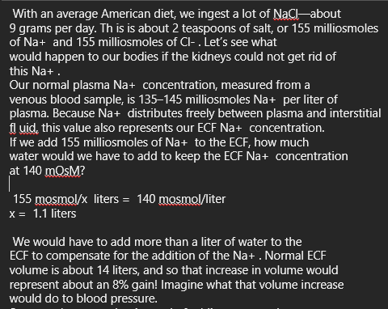

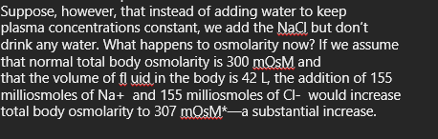

**20.3 Sodium Balance and ECF Volume 43:34. FINSIH THIS UP, then MED CHEM.**

* The hormone that regulates potassium and sodium and reabsorption is **aldosterone**.
  + It is secreted by the **ADRENAL CORTEX**, the **adrenal** **GLAND**, sitting on top of the kidney.
    - Recall that the adrenal gland has degenerated post-ganglionic cells that belong to the sympathetic nervous system—they secrete adrenaline.
      * The cortex secretes corticosteroid, glucocorticoids—one of them being **aldosterone**
        + **Whose tartget are the distal convoluted tubule.**
* In the distal tubule and in the collecting duct, there are these cells that produce aldosterone receptors that are cytoplasmic. Why? Because hormones are lipophilic……
  + These cells are called **principle cells**(?).

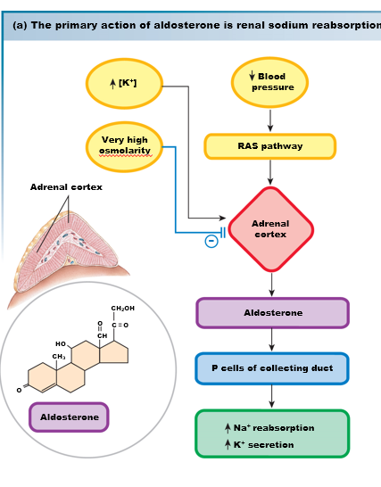

Figure 20.9(b) Aldosterone

* + Principle cells express…
    - Basolateral membrane will express the classic Na-K- ATPase pump.
    - Apical transports will be the potassium leak channel, sodium channels,
  + The yellow dot represents aldosterone that crosses the plasma membrane because it’s a steroid.
  + It binds to cytoplasmic receptors, which then regulates transcription of sodium potassium transporters in both membranes.

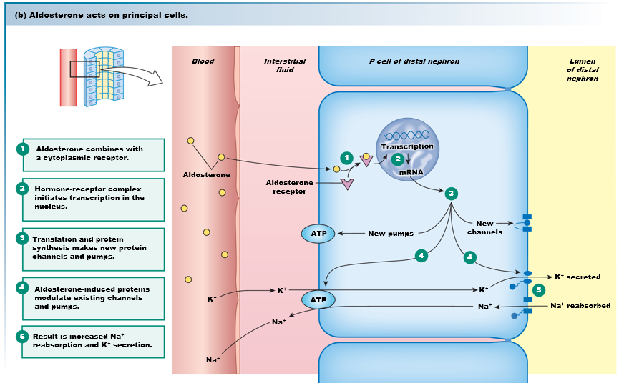

**The Renin-Angiotensin Pathway**

* WHAT CAUSES ALDOSTERONE SECRECTION?
  + **DIRECCT DECREASE IN BLOOD PRESSURE CAUSES GRANULAR CELLS TO RELEASE RENIN***
  + And if you look at the image, what’s happening is
    - NET sodium reabsorption AND
    - Loss of potassium
      * Or rather at the expense of potassium, which is excrected into the urine at the expense of Na+ reabsorption.
  + And we already know that sodium causes increase in blood volume and blood pressure. – as discussed earlier.
  + So let’s think about what would cause aldosterone to be released from the adrenal cortex.
    - **The main pathway for aldosterone release is triggered by angiotensin.**
    - **Angiotension** is actually produced by the LIVER (not the kidney), constantly produced by the liver—in an INACTIVE FORM called **angiotensinogen**.
      * The suffix (-ogen) represents inactive).
    - **Angiotensionogen** is converted to angiotension I by an enzyme secreted by granular cells in the juxtaglomerular apparatus—ths enzme is called RENIN.
  + (overview) LIVER produced angiotensinogen => converted to angiotension 1 by KIDNEY’s juxtaglomerular apparatus through glomular cell’s RENIN.
    - **Angiotensin 1 is NOT active yet, but it’s one step closer to become to most potent vasoconstrictor in nature, which is angiotensin 2**.
    - Angiotension 2 has a super short half life of 1m inute, which means an immediate effect.
    - AND IT MAKES TOTAL SENSE that the final activator of angiotensin 1 to angiotension 2 is produced **by the endotheital wall**—if **angiotension is a vasoconstrictor**, give power to the blood vessels--- the enzyme is called **ACE** (angiotensin-converting enzymes).
      * and you’ve probably heard of vasodilating drugs, which are ACE INHIBTORS, stopping the final step of Angiotension activators.
  + WHAT ARE THE TARGETS OF ANGIOTENSION?
    - MULTIPLE. That’s why it’s so powerful. Five different targets that are directly or indirectly devoted to increasing blood volume/and or blood pressure.
    - In response to angiotensin II
      * Arterioles: vasoconstriction => increase in blood pressure
      * Cardiovascular control center also has angiotension receptors: there are four subtypes that are either GQ or GI coupled:
        + GQ is coupled with phospholipase C and IP3

Which you know in smooth muscle cause contraction.

* + - * + And now you understand why arterioles will contract
        + But in the cardiovascular control centor in the medulla oblognata, elvated calcium and IP3 is hyperexcitatory—which his going to activate the cardiovascular response to induce an increase in blood pressure.
      * In the HYPOTHALAMUS: angiotension II causes the release of vasopressin, which we know increases blood volume => increase pressure.
        + Explain how vasopressin…
      * **NOW FINALLY GOING BACK TO ALDOSTERONE**, in the adrenal cortex, the adrenal cortex responses with aldosterone secretion, which as we saw in the previous slide CAUSES SODIUM REABSORPTION WHICH INCREASES BLOOD VOLUME, WHICH INCREASES BLOOD PRESSURE…how again?
        + and now we finally understand that the tubule itself produces more sodium channels in the apical membrane(?) in response to angiotension.
* NOW LET’S REMIND OURSELVES HOW RENIN IS PRODUCED.
  + The stimulus for renin production is a drop in blood pressure
    - Which his either **directly** activating granular cells
      * But as we know the cardiovascular control center responds to blood pressure, and the GRANULAR CELLS ARE DIRECTLY INNVERATED BY SYMPATHETHIC FIBERS, so cardiovascular control center turn on the sympathetic fibers that “zap” granular cells and cause them to screte renin.
    - **The other** pathway, we already learned above. (long pathway)
      * **The macular cells** sense the sodium concentration in the filtrate. And a **low** sodium transport activate paracrines from the maculadensa cells that then talk to the granular cells that makes them secrete renin.
  + **THUS THERE ARE THREE SOURCES IN CONCLUSION**
    - **-** blood pressure that directly activates granular
    - - blood pressure also activates sympathetic innversation and granular cells through the cardiovascular controls.
    - - low sodium transport activates macula densa cell which then turn on the granular cells through paracrine
      * These paracrines are nitric oxide, etc.

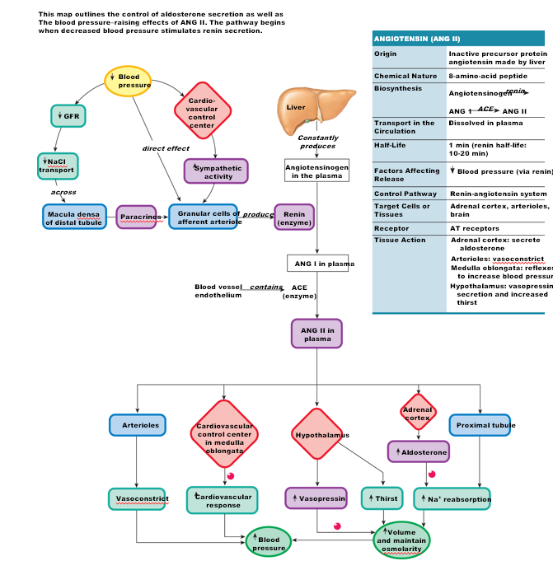

**Natriuretic Peptides Promote Na+ and Water Excretion**

* Increase in blood volume causes an increase in stretch of the atria and ventricles.
* The myocardial cells in the atria and the ventricles in response to stretch secrete hormones known as (because they regulate sodium reabsorption), known as **Natriuretic peptides**)
  + Both ANP and BNP
    - ANP – coming out of atria
    - BNP – coming out of ventricle, and that’s because the Brain has a receptors for the ventricular form of the Natriuretic peptides.
* Natriuretic peptides induced aldosterone secrection (??), which then increases sodium reabsorption. (???)
* Increase blood volume => stretch heart chambers => release of Natriuretic peptides (distinguish the two).
  + They act on the hypothalamus and and decrease vasopressin.
    - IF YOU THINK ABOUT IT, THE THING WITH natriuretic peptides is that they ARE SIGNLAING HIGH-BLOOD PRESSURE (WHEN CONSIDERING HOW THEY’RE EVEN RELEASED). THUS, decreasing vasopressin, causes halt of aquaporin production, and induces for more H2O to be excrected because it’s not being absorbed in the collecting duct or distal tubule anymore. Since technically, both the collecting and distal tubule are imperable to water when not in the prescene of ADH (vasopressin)
  + The response of the kidney to NP is to … can you guess what it is if we’re counteracting high blood pressure? That’s fucking right—**decrease sodium reabsorption!** A
    - HOW? WELL THINK ABOUT HOW SODIUM REABSORPTION HAPPENS IN THE FIRST PLACE – aldosterone from the adrenal cortex/gland
      * Thus these peptides,
        + The response to NP on the **adrenal cortex** is to decrease aldosterone secretion
  + The response to NP on the medulla oblongta, which is part of the cardiovascular control center will decrease sympathetic output, which is STOPS FIRING INTO THE GRANULAR CELLS
  + AND decreased sympathetic activity that causes renin activation (???)
* TO UNDERSTAND THIS, -- THE JUXTAGLOMERULAR SIGNAL IS MEANT TO INCREASE BLOOD PRESSURE RHTOUGH ALDOSTERONE AND ANGIOTENSION
  + SO THINK ABOUT THE HEART PEPTIDES AS THE OPPOSSITE MECHANISM

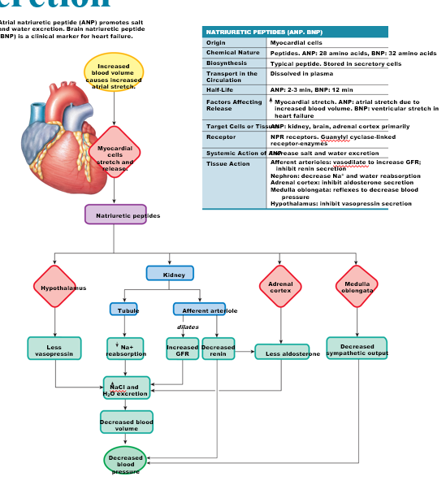

- like the heart that is a gland, the stomach is as well… which secretes a hormone that controls blood pressure—what is it?

20.4 Potassium Balance

* **What’s the issue with aldosterone**?
  + Increase in sodium reabsorption, as you recall, comes at the expense of potassium loss.
  + The most potent effect of aldosterone is expression of potassium channels in the apical membrane, and the sodium-potassim pump in the basolateral(???)
    - So one risk of sustained, low blood pressure, is the loss of potassium.
    - As the body is trying to compensate by absorbing sodium
    - And if you think of scnerios, blood loss by hemoorages, or chronic low blood pressure—
      * These can lead to **hypokalemia**.
        + If we’re talking about muscles, hypokalemia causes muscle weakness, loss of respiratory failure,
      * ~~In HYPERkalemia, you get cardiac arrhythmias.~~
      * Disturbances in K+ balance include kidney disease, diarrhea, and diuretics

20.6 Integrated Control of Volume and Osmolarity (TIME TO PUT ALL THREE TOGETHER BABY)

* 1:14:00 – 1:17:00

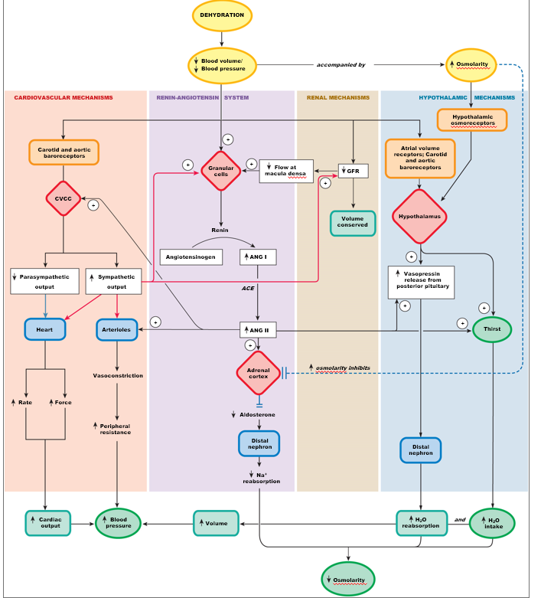

**20.7 Acid–Base Balance**

* We learned that the major buffer system in the plasma and ECF is the bicarbonate buffer.
  + When you combine CO2 and water, either spontaneously or by CA, to make carbonic acid, and becomes bicarbonate and H+.
* We learned that CO2 are regulated by ventiliation.
* Also, what determines the ability of a molecule to lose a proton is the **dissociation constant**, and bicarbonate has a dissociation constant around **6.1.**
  + Thus the highest buffering buffer power is around a pH of 6.1.
    - But 6.1 +- 1, gives us 7.1, which gives us severe acidosis… if compared to physiological pH which is 7.4
      * The message here.. is hmm… the main physiological buffer has a pKa that does not sell it as the best physiological buffer :/--the best one is pKa = 7.4, which is not the case.
  + HOWEVER, remember hendersen hasselbach equation
    - pH = pKa + log (A-/HA) .
      * a buffer would ideally have the *same* around of A- and HA, because if you have the same amount of both forms you have the same ability to neutralize both acids and base, which means when the ratio of 1.
        + Log(1) = 0 ; pH = pKa.
      * Though this is not the case for biocarbonate, and yet, it is our physiological buffer.
  + HOWEVER, this is made possible because our body homeostatically “cheat the system,” and manipulate the ratio of base and acids to make the pH = 7.4.
    - **Bicarbonate to acids is about 20:1**, 20 base for 1 acid.
      * **pH = 6.1 + log(20/1) =7.4…**
    - HOW DO WE MANIPULATE THE AMOUNT OF CONJUGATE BASE AND ACID IN QUESTION?
      * WHO IS THE CONJUGATE BASE?
      * WHO IS THE ACID?
        + CARBONIC ACID

WHICH IS THE SAME AS CO2, WHICH IS THE SOURCE OF CARBONIC ACID.

WHO REGULATES CO2levels? THE LUNGS. VENTILIATION

* + - * SO WHO REGULATES CONJUGATE BASes (BICARBONATE??
      * **THE K I D N E Y S DOES.**
* **If kidney function**/ventiliation function, we can have either acidosis or alkalosis.
  + **Acidosis** makes our neurons less excitatory
  + **Alkalosis** makes our neurons hyperexcitatory.
* Which is easier to achieve? Acidosis----alkalosis is much after to achieve.
  + Acidosis: like lactate acidosis… ketoacidosis.
* Alkalosis is less common because it’s so life threatening.
  + Because it might lead to tetanoic respiratory paralysis.
    - Causes albumin to stay with negative charges (deprotonated), and that cause albumin which is the most abundant protein to trap calcium, which makes your blood hypocalcimic, and low calcium levels depolarizes motor neurons, because it increases sodium influx, and your muscles are contracting faster than relaxing, and thus tetanus, and respiratory plaralysis. NOT ON EXAM BUT FUCK IT.

**Acids and Bases in the Body Come from Many Sources**

* The input of protons comes from diet and metabolism.
  + In our diet, amino acids and fatty acids provide protons
  + In metabolism, lactic acidosis, ketobodies that deprotonate in plasma.
* The plasma contains bicarbonate buffer, proteins, hemoglobin (is also a buffer), phosphate buffers,
* And phosphate buffers.

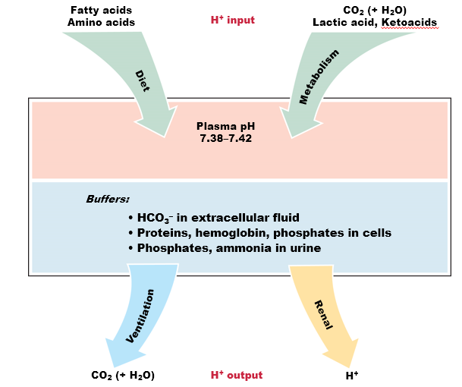

**pH Homeostasis Depends on Buffers, Lungs, and Kidneys**

* **Ventilation** as mentioned earlier regulates CO2 levels, but this only accounts for 70%.
  + **Meaning,** our lungs can only regulate 70% of CO2 when it comes to buffer
  + **The other 25% RELIES ON KIDNEY FUNCTION**
    - **THE KIDNEY ALSO SECRETES PROTONS AND NOT ONLY BICARBONATE**.

**Figure 20.15 Respiratory compensation for metabolic acidosis**

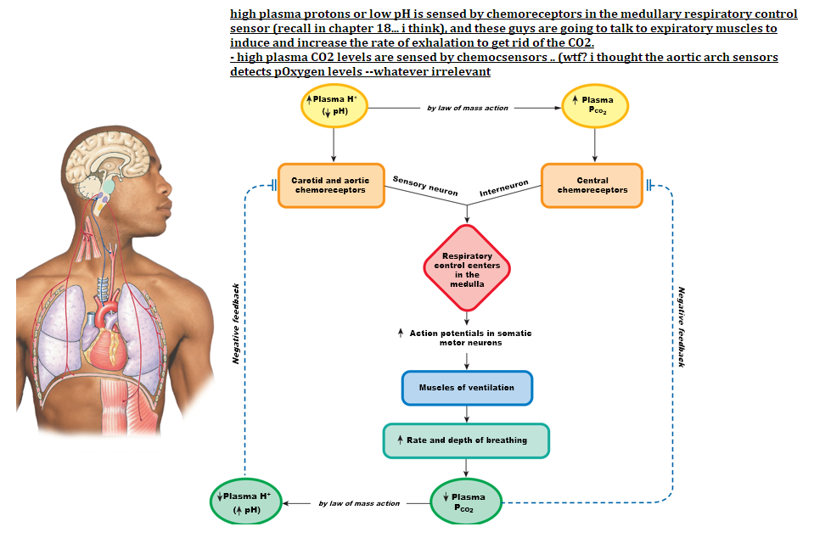

* WE KNOW THE STORY ABOVE. (ch18)

Figure 20.16 Overview of renal compensation for acidosis

* In the kidney, the **distal convoluted tubule and collecting duct** have cells dedicated to,
  + in the case of acidosis, reabsorption of the base, so we neutralize acidosis.
  + If in the case of alkalosis, reabsorption of protons, to neutralize bases.
  + MAKES SENSE.

WTF**… bicarbonate is reabsorbed in the proximal convoluted tubule**

FIGURE BELOW IS A VERY GENEIC MECHANISM OF HANDINGGLING

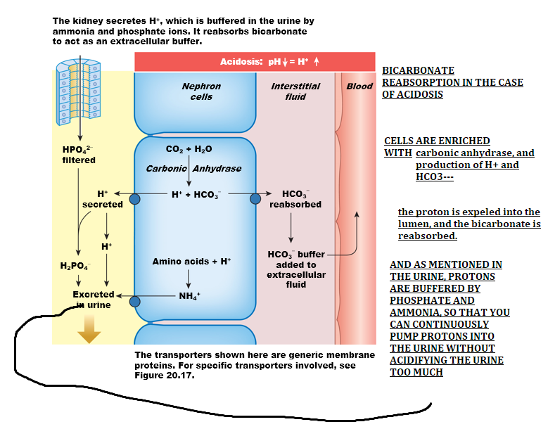

**Kidneys Use Ammonia and Phosphate Buffers**

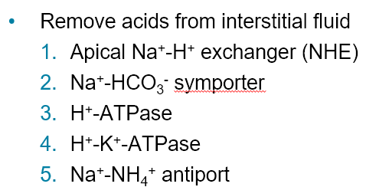

* WHY IS Na+-NH4+ antiport? Remember, ammonia buffers proton secrection
* Damn man so many protons transporters.

**Figure 20.17 The proximal tubule reabsorbs filtered bicarbonate**

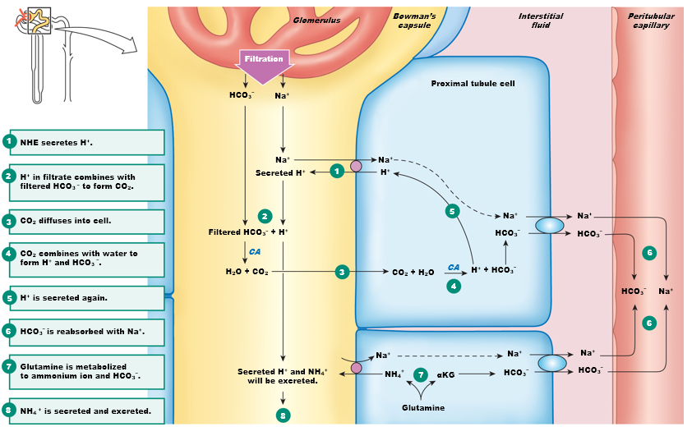

**THIS IS THE SAME IMAGE AS ABOVE.**

**LET’S MOVE ON TO THIS DISTAL CONVOLUTED TUBULE AND COLLECTING DUCTS**

**Figure 20.18 Intercalated cells function in acid-base disturbances**

* There are cells intercalated inbetween the regular endothelial cells in the collecting ducts, (there are normal cells dedicated to reabsorption of potassium, sodium, chloride), and then **there are cells that specialized in making proton transporters.**
* THERE ARE TWO TYPES THAT ARE MIRROR IMAGE OF EACH OTHER. A and B.
  + TYPEA: proton transporters are in the apical membrane
    - Absorbs CO2 during acidosis, makes bicarbonate and H+, then obviously secretes H+ into the urine, and pumps HCO3 back into the blood as a buffer, counteracting the thing.
      * JUST UNDERSTAND THIS ABOVE ALL ELSE: there are proton pumps in the apical membrane in type A cells, and they will because of that excrect protons, and in the basolateral side, there is this **bicarbonate-chloride exchanger, and obviously even if not shown there are chloride and K+ leak channels.**
  + TYPE B: proton transporters are in the basolateral membrane.

One question that im fucking sure that will be asked is “when do you see leak channels in the apical membrane?” and this will be clear if you realize that in alkalosis, you would want to remove bicarbonate through the bicarbonate-chloride exchanger, and thus, you’ll also need leak channels in the apical membrane for type B cells.

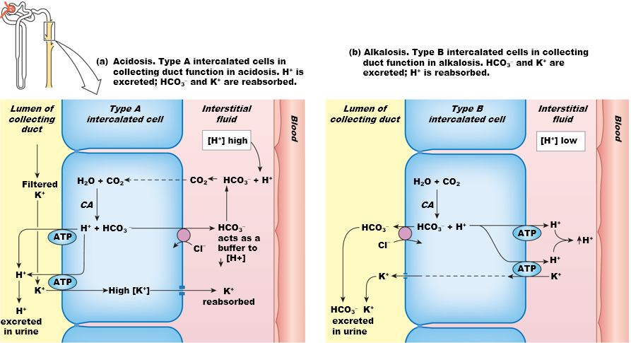

**Acid-base disturbances may be respiratory or metabolic**

* Acidosis and alkalosis could be caused by respiratory function, but can also be caused by metabolic function. ]
* Differentiate respiratory and metabolic acidosis and alkalosis.
* IN THE CASE OF RESPIRATORY acidosis, it is caused by increased in partial pressure of CO2.
  + Don’t overthink it. CO2 => more H+ due to carbonic acid dissociation
    - Examples: respitraotyr disfunction, empshaya, COPD, are good examples of chronically high CO2 levels.
    - THIS LEADS TO increased proton concentrations in the plasma, pH is decreased,
      * And the RESPONSE mechanism to counteract this should be type A intercalated.
        + TYPE A FOR ACIDOSIS>
* If acidosis is metabolic, not respiratory, CO2 levels should not be what’s causing this. Obviously. Metabolic acidosis happens when you accumulate lactate, which means you’re skipping mitochondria-krebcycle, which is the source of CO2. So it makes no sense to talk about CO2 increase in metabolic acidosis.
  + But it’s acidosis. We have high proton increase, a decrease in pH, and if it’s not cause by CO2, it HAS to be a drop in bicarbonate.

ALKALOSIS

* If respiratory alkalosis, it’s going to be a DROP in CO2.
* If it’s metabolic, then it’s going to be because of an increase in bicarbonate.
  + Usually caused by intoxiciation

INTUTITVIE AF.

If talking about respiratory => CO2 levels change

If talking about metabolic => bicarbonarte levels change.

* Try to see what compensatory mechanisms occur,.
  + Try to bring it back to normal change, but it doesn’t always happen, like in COPD. As we learned that CO2 levels are constantly high, and we downregulate the chemoreceptors in the CNS, so now we rely on the pherphial receptors, which are blind to CO2, and only respond to oxygen drop, but only respond when pO2 drops to 60. ….

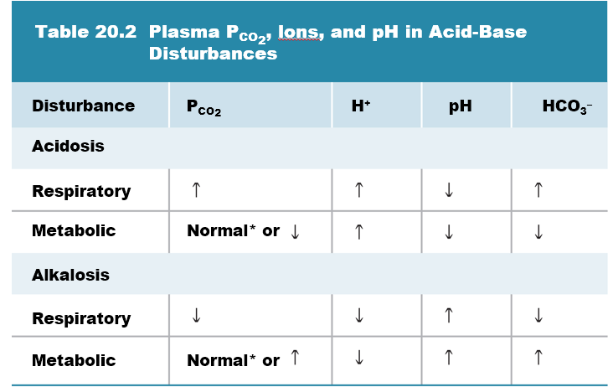

Figure 20.19 Acid-base disturbances may be incompletely compensated [EXAM]

* Modified Henderson hasselblach, since we cant measure carbonic acid. It’s a weak acid, dissocating constantly, but we can measure pCO2, but first **you need to account for the solubility of the gas**.
* SO YOU REALLY NEED TO PLAY WITH SITUATIONS, AND PARTIAL PRESSURES OF CO2, AND I’m GOING TO BE ASKING YOU IN DIFFERENT SCENERIOS, WHAT HAPPENS TO pH at different partial pressures of CO2, and I might be talking alveolus, the arteriole end of the capillary (wtf?), the venous end (wtf)?, and im never going to tell you what the arteriole or venous end.
  + YOU SHOULD KNOW: 40 mmHg = arteriole
  + YOU SHOULD KNOW: 46 mmHg CO2 = venous end.

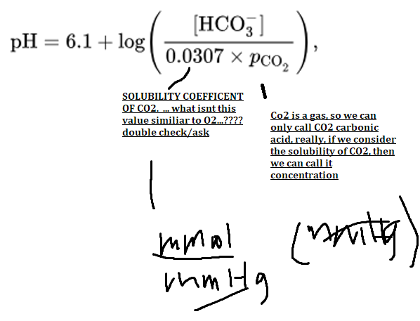

## Minnal’s and that other dude Presentation: SKIPPED

## Chapter 21:

* In the oral cavity, we have three glands **the parotid, sublingual, and submandibular salivary glands**. We secrete about 1.5 liters of Silvia per day.
* We know that salivary gland is under the control of the autonomous nervous system, and the activator here is ACh on M3 receptors cause siliva secrection.

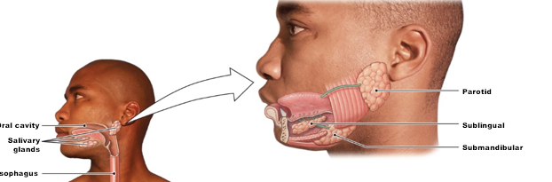

* The oral cavity continues into the pharynx, the esophohagus, which then dilates itself into the stomach.
* Seperating the stomach from the intestines is a smooth muscle sphincter called the **pyloric valve.**
* And then from this point on is the small => large intestines
  + Small in diameter only, not in length.
* Secreting into the first “12-cm” of the small intestine is a pair of accessory glands known as “the liver through the bladder, (remember the gallbladder is bladder not a gland), the liver the gland here, and then the pancreas.
* If we stop at the stomache first, I want to remind you of the different regions.
  + The anterior extension of the stomach is known as the “backdoor” – **FUNDUS**.
    - Most of the **bolus**, which is really a ball of food mixed with stuff, spend about 2/3rd of the time in the fundus.
      * Hence, the fundus is the **storage part of the stomach**.
  + When contraction occurs, food moves into the **antrum**, where digestion is going to start—especially of proteins.

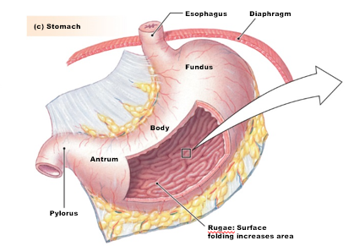

First, let’s consider structure function relationships.

* If we were to look at the epithelium, we’ll notice that there are several layers of, but one layer is called the **mucosa**, because these cells are primarily globlet cells, which secrete mucus.
* But the gland really is protected inside of the “crypt” which contains secrectory cells aside from globets, like cells that secrete acid (hydrochloride), cells that secrete hormones that we’ll talk about today, cells that secrete digestive enzymes that breaks down proteins.
* Underneath the muscous is a tiny layer of **smooth muscle**, obviously—the digestive tract is surrounded by smooth muscle..this is not novel to us.
  + But the **muscularis mucosae** has the function of changing the surface area of the digestive tube.
    - Contractions of the muscularis mucosa may in the case of the stomach,---open the crypts for gastric secrection—
    - In the case of the intestine, might expose the vilii, which are invaginations of the intestinal wall to increase surface area for absorption.
    - Below the musclaris mucosae is the **sub-mucosa**, and here are nerve branches.
      * In here, you’re going to find lymphatic tubes, veins and arteries branching into …
    - Below the submucosa is the **muscularis externa**, which is the most outer layer of the stomach.
      * And it’s formed by THREE arraganement of muscles. There is a longituinad layer, circular layer, and an “extra” layer that is NOT found in the intestines, which are oblique muscles.
        + **These layers allow for the stomach to contract in ALL directions—thus allowing for the main function of the stomach: MECHANICAL DIGESTION**.
    - Lastly, there’s connective tissue surrounding the whole thing.—**serosa**
* FROM THE PHERPHERIAL TOWARDS THE LUMEN:
  + Serosa => muscalaris externa => submucosa => submuscoa musclaris => then the mucosa itself. Asdasdasdasd
* Once again, what’s the function of the muscularis mucosae?
  + Smooth muscle that controls the crypt, which controls secrecction. 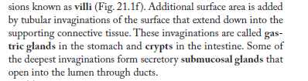

W

NERVE BRANCHES IN THE SUBMUCOSA, WHICH ALSO SEPERATING THE TWO MUSCLE LAYERS IN muscularsis extern…..

* And these nerves form what is called the **enteric nervous system**
  + Think of these nerve branches as the CNS of your stomach.
  + Gastric entrerologist refer to this as the second brain because in this region you can have completely independent integration from the CNS.
    - So even if you cut the nerves in the CNS/vagus, you still have autonomous function of the digestive tract.
* the enteric nervous system, again, can be automous and incredibly complex, and it secretes about **30 different kinds of neuropeptides** (of neurotransmitters) all different from ACh and adrenaline.
  + **But it’s very clear that they control the basic functions of like molitity, serection, and digestion, but they also control the feeling of hunger and satiation.**.
    - **So** the enteric system: (4)
      * **Secrection, digestion, absorption, and motility**

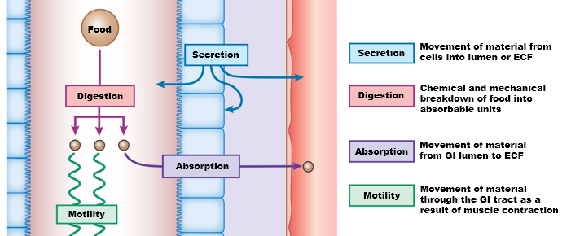

HOW ARE THESE FOUR FUNCTIONS REGULATED in each major part of the digestion part?

* Secrection is often not thought of because you’d think the stomach is mostly absorption, but we secrete about 9 liters of water into the tube, every day—it’s 9 because it accounts for 2L of liquid that is already in your diet

**We Secrete More Fluid than We Ingest**

* YET, we only lose about 100mL of all of these selections into the feces---incredibly efficient at preventing water loss.
* So you’d can imagine that loss of water through the digestive tract when it happens is a big deal—and we tend to lose water through diarrhea and vomiting.
* Though 9-liters of imput, 9L removed—mass balance is there.

Motility: GI Smooth Muscles Contracts Spontaneously

* Moltility is represented by contraction of smooth muscles
* These contractions occur SPONTANEOUSLY**.** 
  + **There are modified pace maker potentials in smooth muscles**.
  + That in the intestines these smooth muscles are SINGLE UNIT.
    - Remember that that means?
      * That they all contract at once because of the ABUNDANCE OF GAP JUNCTIONS.
  + But these pacemaker cells are way way slower than cardiac pacemakers.
    - Happens only 3-12 times PER MINUTES—so incredibly slow; and not always they’ll reach threshold. So not always depolarization leads to muscle contraction.
    - But when it does—then you have…a switch, and i
    - **if several action potentials are firing** at the same time/close proximity in time then you have sustained smooth muscle contractions which is , called **segmental contractions—**like areas about 20 cm of intestine all contracting at once.
      * **SLOW WAVE CONTRACTIONS—which are pace maker initites, but the pacemaker only beats to about 3-12 times per minute—very low freqyuency.**
      * **And it’s really these slow ways contraction that command MOLTITY.**

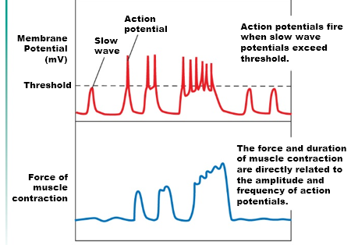

**GI Smooth Muscle Exhibits Different Patterns of Contraction**

THERE ARE THREE TYPES OF CONTRACTIONS

* Single (peristalic):
  + In (c), is an example of peristaltis contraction, which is caused by the CIRCULAR smooth muscle around the tube.
  + The stretch by the bolus opens stretch activated Ca2+ channels, which then propels the bolus forward, pushing the bolus 4cm per second. These contractions are sustained, and are stronger than gravitational pull.
* Segmental:
  + Contraction of the WHOLE segment of the intestine, what occurs is the MIXING OF food, occurring with segments of perittatlistic happening at the same time.
* Contractions of the whole system (?)

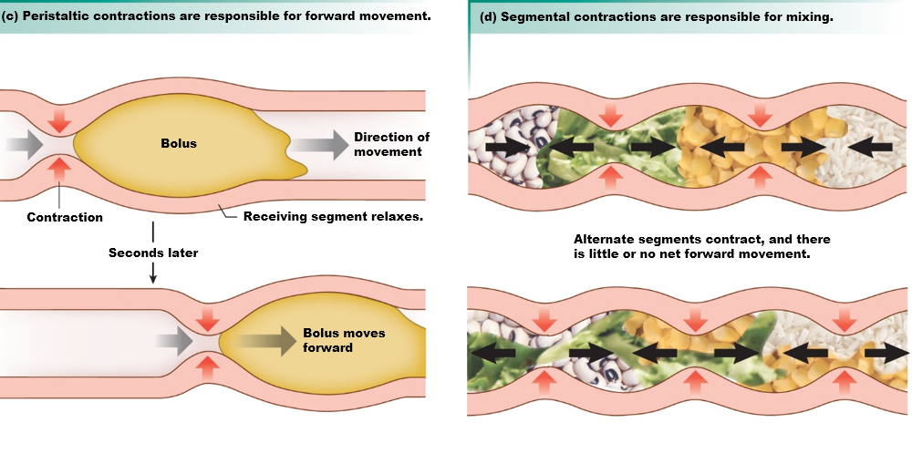

21.3 Regulation of GI Function (how is molitity and secrection regulated)

- this is a little overview

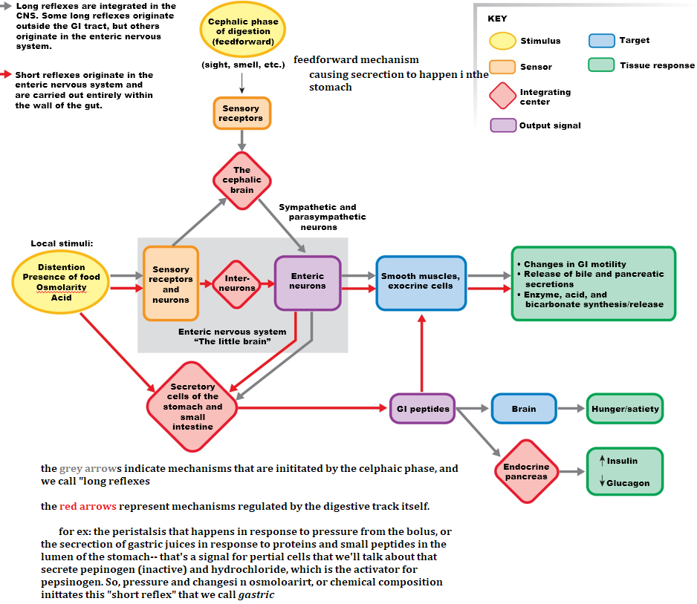

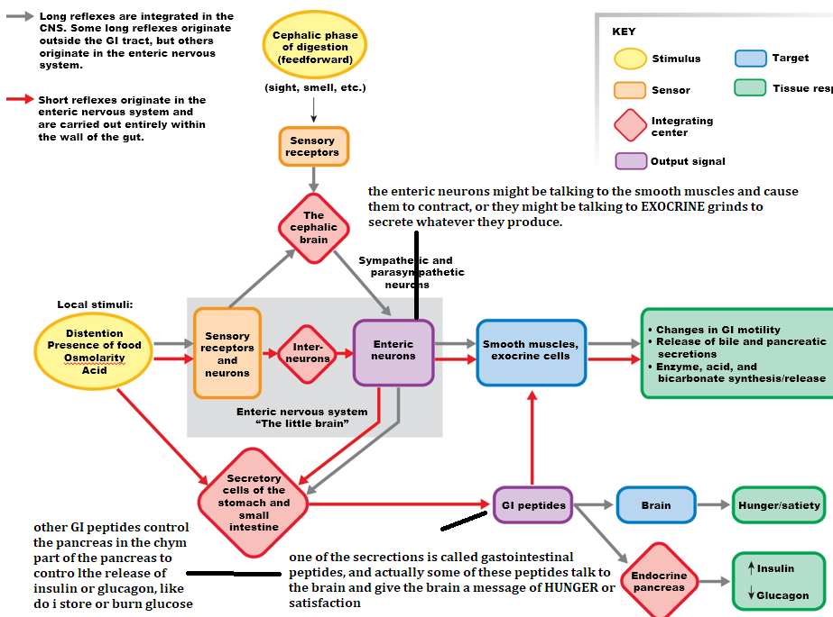

Table 21.1 The GI Hormones

Eat this for breakfast… but just to give you examples

* STOMACH: GASTRIN: induces acid secrection => because the target of gastrin ECL and parietal cells.(the only one mentioned for the stomach)
* SECRECTIN: is ***also*** **gastrointestinal peptide** secreted by duoudine, and the target is are pancreatic cells.
  + Secrectin is released in response to the chemical composition in the doudemon.
    - If it is rich in carbohydrates, secretin is secreted there => goes to the pancreas => and tells the pancreas *hey…handle this carbohydrate that is about to come to the blood circulation*
* TWO **OTHER** GUYS THAT CONTROL pancreas:
  + **Gastric inhibitory peptide** (GIP): -OR -**glucose-insulino-peptide** 
    - The reason why it was called inhibitory has historical roots. During surgery they just threw it in there and saw that it inhibited moltitity. However that was because it was in high concentrations, but when they tried to build a dose-dependent curve—they found that in mmolar levels, GIP is actually controlling the pancreas.
      * By stimulating insulin release (feedforward)
* Really the main message here is that for gastrointestinal peptides like secretin, GIP, and glucagon-like peptide, are SECRETED IN RESPONSE OF *CHEMICAL MAKEUP OF THE* DUODEMN *(duodenal??), --present in different parts of the **duodenal**
* In the duodenal, the epithelium here, senses a “fat-ridge” chyme or bolus, and then the hormone synthesized secreted is **CCK** and CCK “here” one of the most recently discovered function is that it tells your brain—look we have fat; and thus we’re satisfied,
  + But CCK also induces the pancreas to secrete LIPASES, so that we can handle the fat.
* SO THE TAKE HOME MESSAGE HERE, ONCE AGAIN, gastrinointestinal peptides are secreted in response to the chemical response of the chyme, and they control glands that secrete each one of these things in the 21.1.

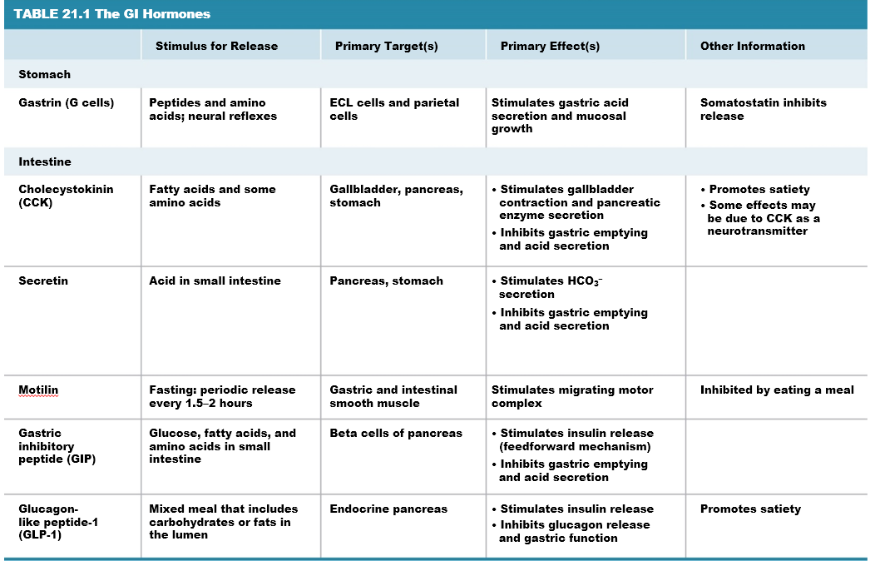

Figure 21.6 Overview of digestive function

* The chewing action that mixes food, and the action of the tongue over the food and the mixing of siliva turns the food into a ball, making it mucuousy and bally—bolus.
* There is very little secrection in the espohgaous, but the digestion happening in the eosphohaous is really in response to the siliva,
  + The eosphoagous releases **amylase, which breaks down starch.**
* So the bottom line here is digestion is happening everywhere along the tract, but what CHANGES IS WHO IS BEING SECRETED—AND HOW IS MOLTITLTY CONTROLLED.
* AS A REMINDER, YOU DON’T SEE GASTROINTESTINAL PEPTIDES UNTIL YOU GET TO THE STOMACH.

**21.4 Integrated Function: The Cephalic and Gastric Phases**

- the celphaic phase is elicted by the hypothalamus, and the hypothalamus sends neurons into the medulla oblgonata, and the output of the medulla is through the VAGUS nerve that talks to the ENTERIC PLEXUS (in the submucosa and the muscolaris externum) – just reminding you of where it is.

* The preganglionc neuron is the vagus—does that make sense?
* And the enteric neuron are now post-ganglionic---it’s still autonomous…
* If you’re with me, who or what is secreted into the enteric nervous system?
  + It literally has to be ACh—since all preganglionic secretes.
    - ACh is the same released in the sympathetic, parasympathetic.
* You should think of rest and digest for parasympathetic—which intnervates the enteric plexus, and ACh here is excitatory, the digest part is secrection.
  + So ACh induces secrection, and he mentioned in the past about collecting ACh gum and people will drool uncontrollably.
* ACh activates postganglionic nerves—and that now secrete the 30 something neuronpeptides, and these neuropeptides find targts in the stomach and the intestines, who respond with secrection and motility.
* Even if we cut the vagus nerve, we’ll still get a response because there are sensory neurons in the wall of the epithelium, and these sensory neurosn talk back to the enteric plexus through interneurons in the plexus.
* Realize that the gastric can happen without the gastric phase—now we now. There’s sensory input—there’s integration here; and that really makes the story. The ability to process sensory input and deliver a response. Cool? No.

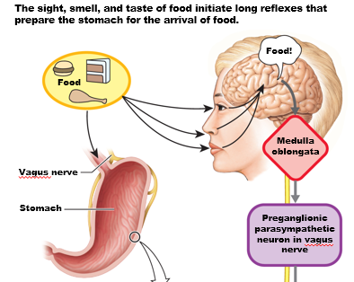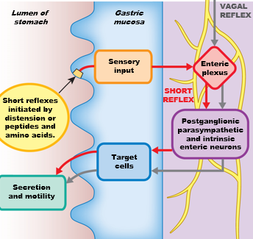

* PEPTIDES PRODUCED IN THE ***STOMACH* DRELIN AND LEPTIN**

LET’S GO BACK TO THE STOMACH: TO **THE GASTRIC GLAND**

Gastric Secretions Protect and Digest

* Color coding of the crypt shows us different types of secrectory cells.
* At the opening and the neck of the pit, you have mucus secreting cells: globet cells
* As you go in: you have **parietal** **cells**: secrecting **hydrochloride** (we’ll see how it’s regulated)
* there are cells that secrete histamine and serotonin, both causes motility and smooth **muscle contractions in** **THE WALLS SO THEY SITMULATE SECRECTIONS**
  + and both histamine and serotonin are secreted by **these ECL cells…**

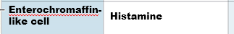

* **And then we have these cells that secrete THE ACTUAL DIGESTIVE ENZYMES KNOWN AS “CHIEF CELLS” –which secrete PEPINOGEN**

How to make sense of al lthis information?

We think of acid when we think of *gastric*, so gastric G cells secrete *gastrin*, the main hormone that tells parietal cells to secrete acid.

And CHIEF secretes the actual enzymes that digest proteins.

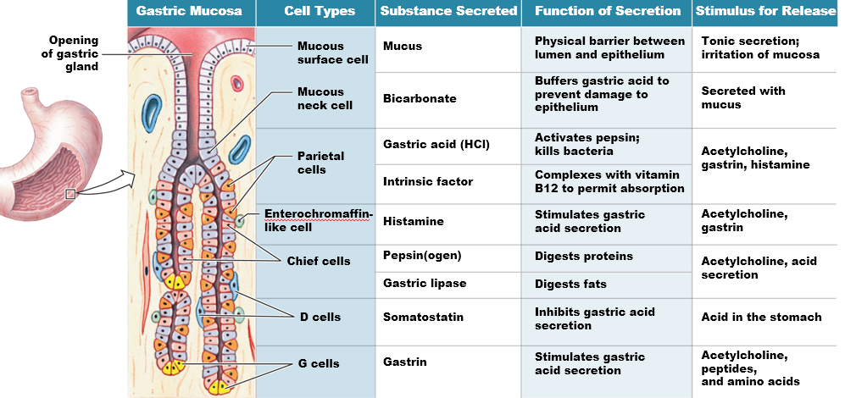

Figure 21.10 Integration of cephalic and gastric phase secretion

1. The celphaic phase delivers ACh to the vagus => into the plexus.
2. The plexus has neurons that innervate parietal cells directly.
   1. As we know parietal cells secrete protons and chloride.
3. HCl by itself stimulates sensory neurons in the walls of the stomach that then talk to the plexus, that also innervates Chief cells, which we know releases pepsinogen).
   1. (So you see how release of hydrochloride also causes the release of pepsinogen?)
4. And the low pH of pepsinogen causes it to be activated into pepsin—the protease that works at low pH.

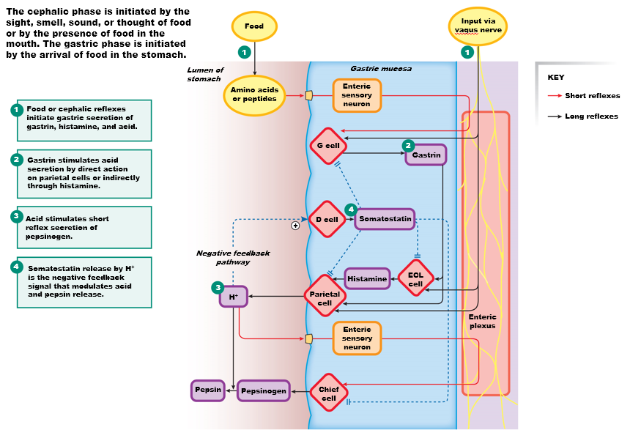

Still referring to the picture above,

* Now that protons decreased the pH in the stomach, that in itself activates another cell called D-cells. D-cells secrete a hormone called **somatostatin**, which inhibits parietal cells.
  + Does that make sense? A negative feedback mechanism in which too much H+ will cause inhibition of parietal cells through D-cell activation from low pH, stopping you from auto-digesting your own damn stomach.
  + SOMATOSTATIN ALSO INHIBITS ECL CELLS, WHICH AS WE KNOW RELEASES HISTAMINE, WHICH THUS INHIBITS MOTILITY, CONTRACTION.
    - HISTAMINE ALSO HAPPENS TO ACTIVATE PARIETAL CELLS, so inhibition of histamine also further stops hydrogen secretion.
* Thus, the process itself is very chemically self-regulated.

Figure 21.9(b-c) Gastric Secretions (this happens first, then the image above)

* Can you remind me of what cells are inverted directly by the enteric plexus?
  + G-cells are innervated directly.
  + And parietal cells
* And we know that innervation of parietal cell starts the whole “shebang” because it induces hydrochloride secrection, which then activates G-cells indirectly through sensory neurons.
* But if you continue to do that you’ll accumulate so much hydrogen protons that will activate D-cells, which cause release of somatostatin, which is pretty much the only inhibitory one for our purposes.
  + What does it inhibit? Look at above man im tired of listening and typing

Figure 21.9(b-c) Gastric Secretions

1. Represents a mucous **secrecting** **bicarbonate**, which protects endothelial cells from the acidic pH, without the mucous you’d be digesting your endothelial.
2. And if you

WHAT IS THE MECHANISM FOR HYDROGEN SECRECTION OF PARITEAL CELLS?

* FINALLY, once you look inside the “pits”, youll see parietal cells.
  + (c), and if it’s secrecting hydrochloride… what might you expect on the apical membrane?
    - THE APICAL MEMBRANE HAS CFTR channels.
    - THE BASOLATERAL MEMBRANE has the bicarbonate-chloride antiporter (Exchanger), which should be FAMILIAR TO YOU—RECALL IT IN THE PROXIMAL CONVOLUTED TUBULE for bicarbonate secrection.
  + So once chloride comes into the cell, al that’s needed is opening of a chloride leak channel.
  + The proton is secrete through a pump known as the PROTON-POTASSIUM PUMP (do not confuse with Na-K pump)
    - **the proton comes from the dissociation of water……….**
  + ONE THING TO WRITE DOWN IS THAT **ANTACIDS (Pepto-Bismol)** ARE INHIBITORS OF THE PROTON-POTASSIYM PUMP [EXAAAAAAAAAAAAAAAAAAAM]
* Wait what’s the purpose fo the bicarbonate-chloride exchanger?
  + To keep equilibrium for more acid production. –and you need an negative charge coming out with the proton… ok…

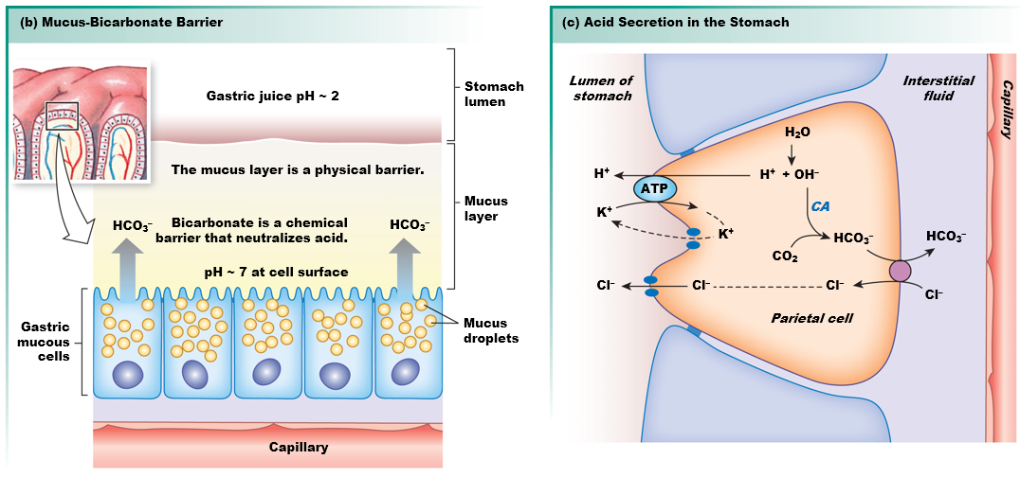

21.6 Integrated Function: The Intestinal Phase (NOW FOR SECRECTION IN THE INTESTINES) and Figure 21.12 The hepatic portal system

* The surface of the intestines, known as microvilli, is lined with cuboid cells in a mono-layer whose apical membrane also has interprojections known as microvillim
  + If we expanded this membrane, the surface area will be like a tennis court, which is the surface area of the intestine
* But in the villi, there are lymph vessels and capillary circulation UNDERLYING THE IMPORTANCE OF a distribution system of absorption
  + And this distrubtion center is sending everything that is absorbed to the LIVER
    - THE LIVER’S FUNCTION IS TO DETOXIFY THINGS, START DISTRIBUTION OF STUFF, AND GETS RID OF **BILIRIBIN**, which is wasted hemoglobin molecules from meat in diet, AND there’s a system that we call **portal** because all the capillary system converges into the door way in the liver, where its detoxified and then pumped into the body.

In a few slides---(we send fats to the lympathitic circulation, and then the lymph drainage goes to the liver, and the fats goes to the lympathic vessels we call lateos…(?), and then they get packed with lipoproteins that makes fat a little more soluble called LDL and HDL.. more on this later.

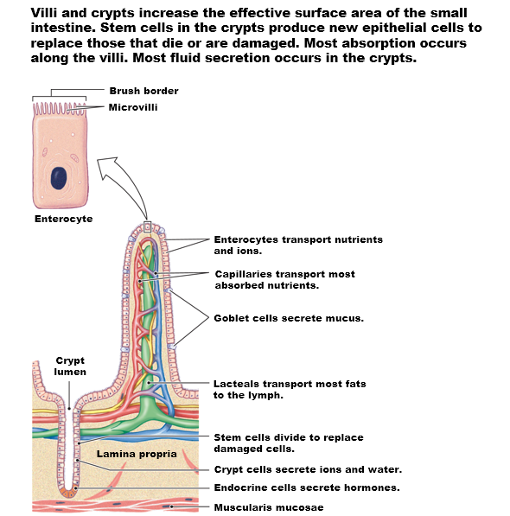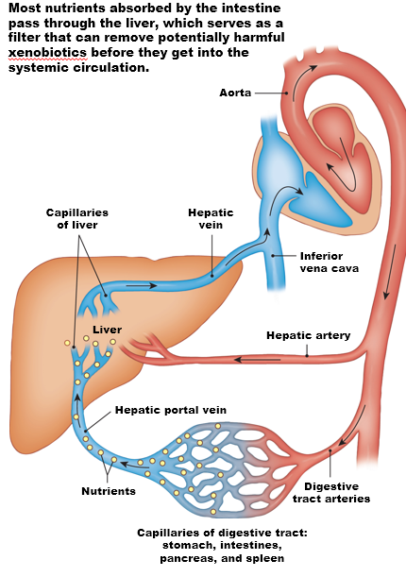

Intestinal Secretions Promote Digestion

* Secrection in the digestive system:
  + Digestive enzymes, **bile**, bicarbonate (because remember chyme coming out of the stomach is acidic, which is convient for pepsin, but not good for lipases, nucleases, and other proteases like trypsin that will keep their action in the intestine so we need to neutralize the pH from bicarbonate secrection in the pancreas.
  + There’s more mucous screction
  + Electrolte balance

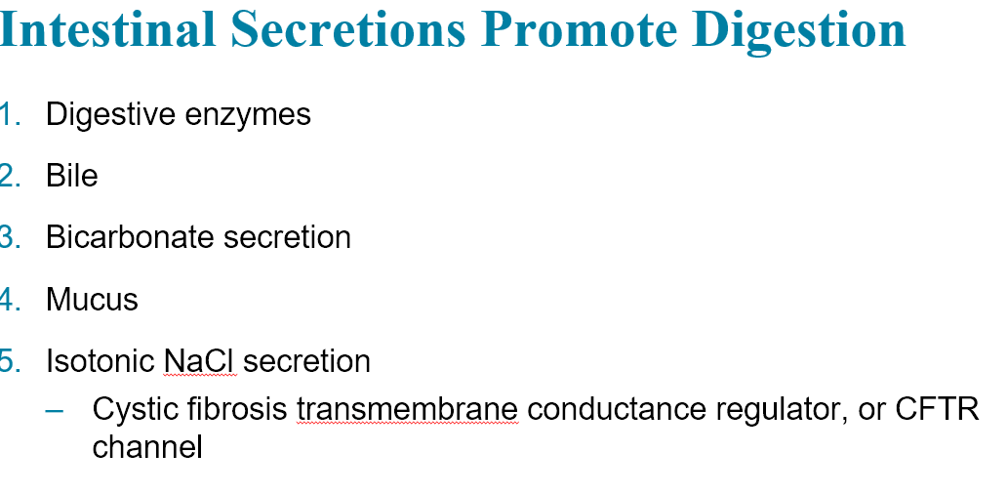

Figure 21.13 Isotonic NaCl secretion

* Sodium-chloride secrection (TWO WAYS IN THE INTESTINE)
  + In the duodemn it’s active through channels
  + But it can also happen in the paracellular way,

Let’s talk paracellular first

* Sodium follows chloride.
* NCCK channel (sodium-chloride-chloride- potassium channel) imports all these solutes,
* And in the basolateral membrane by the famous leak-potassium channel (CTFR), and
  + WHILE NOT SHOWN, THE LEAK POTASSIUM CHANNEL AND THE NA-K PUMP.

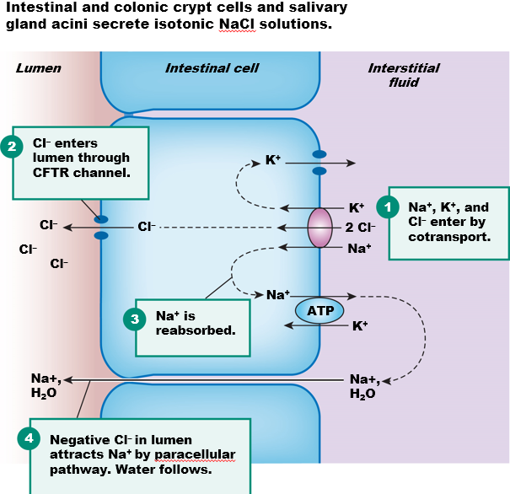 [SAME SLIDE AS THE SECRECTION OF SALINE IN THE THROAT] 50:00

* The allows for sodium, chloride secretion.

The Pancreas Secretes Enzymes and Bicarbonate

* The pancreas has an endocrine portion (endocrine = secrection of hormone into blood)
  + And we know who they are insulin and glucacon secreted b the **islet of lanserhants)**
* And then surrounding those islet is the **exocrine** portion
  + WHICH SECRECTS DIGESTIVE ENZYMES AND BICARBONATES

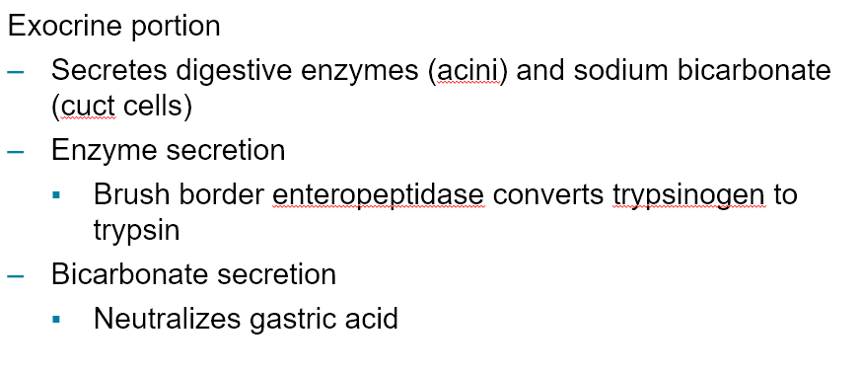

* **The pancreas has these ducts that open into the duodemn, here’s an opening of the duct, and there’s one that actually meets the bile duct called the SPINCHTER OF ODIN, WHICH CONTROLS THE OPENING OF THE TWO DUCTS**
  + ALL pancreatic and liver secretions arrive in the duodenum.

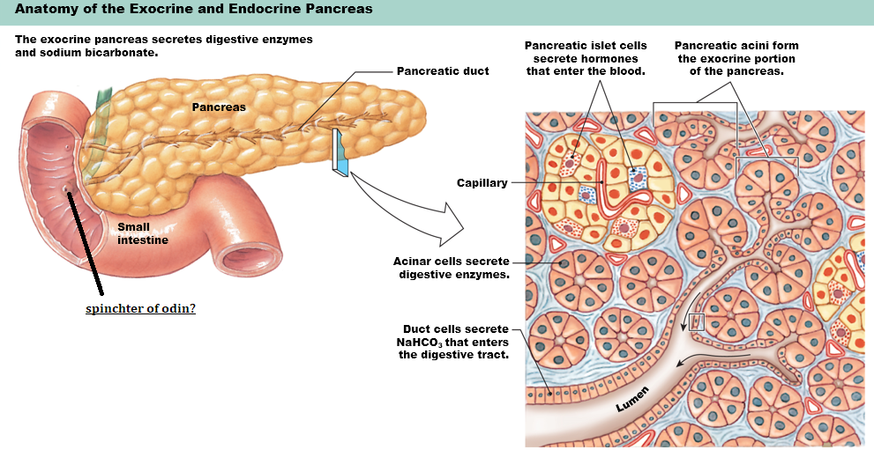

**Figure 21.14 The Pancreas (2 of 2)**

* Most pancreatic enzymes are secreted in the inactive form known as ZYMOGENS.
  + So there are **proteases** being secreted, and they are inactive

UNTIL…a second enzyme from the pancreas gets activated. That enzyme is known as **trypsinogen**, and what activates that enzyme is peptidases from the lining of the lumen known as **enteropeptidases** (intestinal peptidase)

* So it makes sense that the pancreas secretes these inactivate proteases and lipases as well, and it ALSO secretes the key to activating them (trypsinogen), but that key is also inactivate lmfao ok, until it the enteropeptidase “removes” the inactive portion to activate it to become trypsin.
  + So fucking finally trypsin activates all the zymogens.

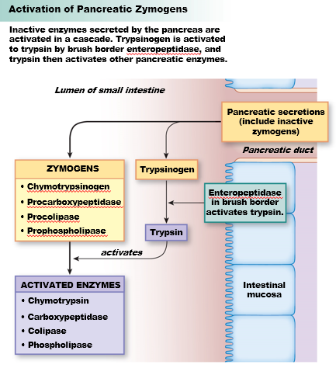

THE OTHER FUNCTION OF THE PANCREAS IS BICARBONATE SECRECTION.

* These enzymes don’t work if the chyme arriving from the stomach is acidic, so you need to neutralize the pH in chyme.
* LET’S SEE HOW.
  + IF WE WANT TO NEUTRALIZE ACIDS, THEN SECRECTION OF BICARBONATE MUST OCCUR ON THE APICAL SIDE. THE ONLY WAY WE KNOW HOW AT THE MOMENT IS THE, yes, you guessed it**, bicarbonate-chloride exchanger**.
  + What’s novel here is that the CFTR (Cl-) leak channel is also on the apical side… WTF.
* Another source of chloride is the NKCC.
  + And if there’s potassium influx, there has to be a leak channel, and a K+ channel.
* THE SOURCE of bicarbonate is the creating of bicarbonate and proton from H2O and CO2.
  + If the point is bicarbonate secrection, then there MUST be a sodium-proton pump on the BASOLATERAL side.

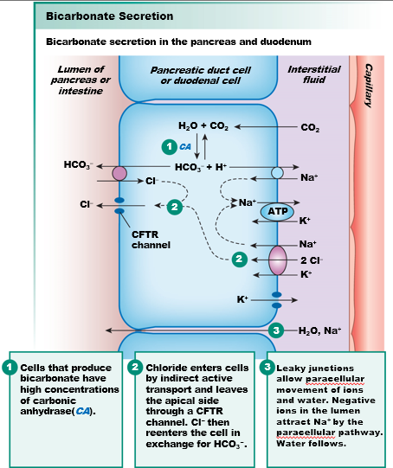

Tl:DR for above: bicarbonate secrection and zymogen excrection of EXOCRINE function.

The Liver Secretes Bile

* Liver secretion is bile, which is salt, pigments, **cholesterol** that is important and removed by the hepatocytes.
* THE MAIN FUNCTION OF BILE IS TO EMULSIFY FAT.
  + TURN BIG GLOBS OF FAT TO SMALLER, THAT CAN NOW BE PENETRATED BY LIPASES.
* Bile pigments are a product of metabolism of heme groups (biliribun) and cytochromes.
* What color is your shit? Brown. So bilirubin is brown (think about brown meat when oxidized).
* The gall bladder is NOT a gland, just a sac, opening into the doudemum.

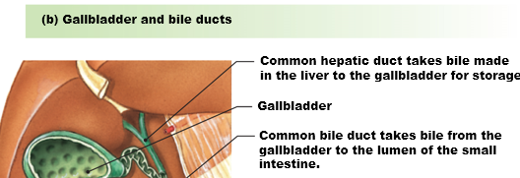

Figure 21.15(a-b) The Liver

* The GLAnD itself, the liver, is formed in an arrangement known as hepatocytes.
* Heptatocytes are structured around the portal veins. The vein as we recall is coming from the intestine and now TOXINS are being absorbed by the hepatocytes and metabolized, and then DUMPED into the green vessels known as the **bile** **ductules** that CONVERGE INTO THE GALL BLADDER.

THUS EVERYTHING COMING OUT OF INTESTINES AFTER ABSORPTION IS DELIVERED TO THE LIVER THROUGH THE PORTAL VEINS and now blood flowing out of the something is going to the heart.

* And toxins are absorbed by heptatocytes, detoxified and sent into the bile ducts, with pour into the gall bladder.

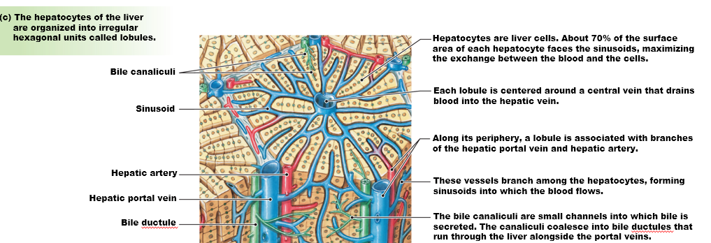

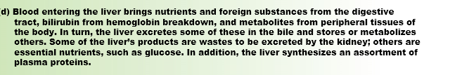

Figure 21.16(a) Digestion and Absorption: of Fats 1:00:00

* One of the major components is the bile-salts.
* Bile-salts “encircle” fats deposits and turn them into micells containing triglycerides, free floating fatty acids and whatnot.
* Triglycerides and free-fatty acids are absorbed by diffusion after they are broken down.
  + So, emulsion of fat turns them into micells, which are then digested by the pancreatic lipases. Free-floating fatty acids can be absorbed by simple diffusions, and packaged into little droplets known as **chylomicrons**

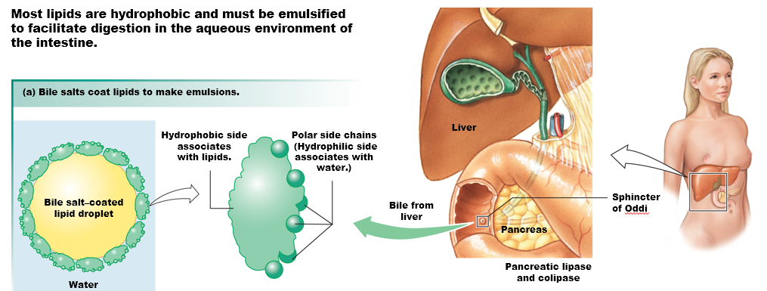

* CHYLOMICRONS ARE SURROUNDED BY A PROTEIN coating that SHIELDS the chylomicon from the blood circulation, which means the endothelial cells cannot reabsorb chylomicrons because they are surrounded by a protein coat.
* Lymphatic’s known as **lacteal** are permeable to these protein coats, and now these guys will be carried into the liver and turned into special chylomicrons because they now have proteins with receptors to cells.
  + These proteins are known as **apolipoproteins** – and if you have a lot of apolipoproteins compared to lipids, then the density of that protein is higher because proteins is more dense.
    - HIGH DENSITY LIPOPROTEIN (HDL)
      * Cholesterol is cholesterol no matter what you call it.
      * But if it’s present in HDL, that simply means you have less cholesterol, and less cholesterol is “less bad”
    - Our cells are actually less permable to LDL because it contains different proteins, which means LDL accumulate in the circulation.
* SO THIS COVERS HOW LIPIDS ARE HANDLED.
  + Cholester does NOT diffuse into the apical membrane, there are actual receptors foerr cholesterol.
    - And there’s a name for this receptor, and A DRUG TRAT INHIBITS THIS RECEPTOR KNOWN AS **STATIN**, which reduces cholesterol.

**HOW ARE CARBS HANDLED?**

* Break down of polysaccharides to maltose, sucrose and lactose.
  + Thus pancreas also secretes amylase.
* Now here’s the apical membrane,
* GLUCOSE WOULD NEVER BE ABLE TO BE ABSORBED BY THE APICAL MEMBRANE BY SIMPLE DIFFUSION. IF YOU BRING THE CHEAT SHEET, YOULL SEE THAT GLUCOSE LEVELS ARE TOO HIGH INTRACELLULARLLY.
  + This opening simple GLUT transport in the apical membrane is counterproductive.
  + YOU NEED FACILITATED DIFFUSION
    - As such you’ll find a **SGLT (glucose or galactoase symporter)**
  + **However, there is a GLUT5, in which FRUCTOSE can diffuse inwards.** 
    - **And that’s why people who are trying to lose weight AVOID fructose.** 
      * **GLUT2 is present on on the basolateral membrane however, for obvious reasons.**
    - **And this is why you give children saline to avoid dehydration and malnutrition, you combine it with a teaspoon of salt, b/c glucose transport requires salt.**
* **What happens if I replace glucose symporters (SGLT) with GLUT transporters?**
  + **Nothing will happen. No glucose absorption.**

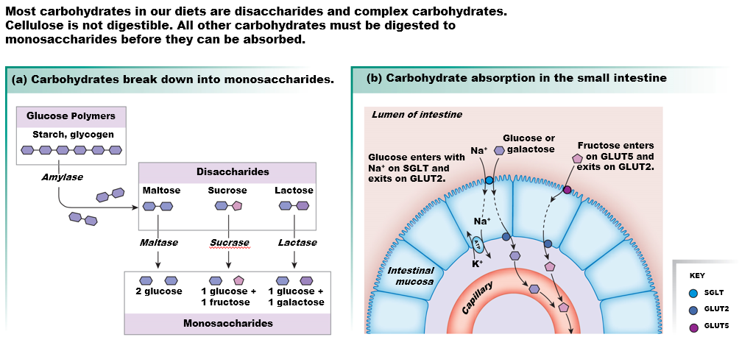

**HOW ARE PROTEINS HANDLED**

* So we already understand that pancreatic secretion (zygomen?) and gastric secrections (pepsin) will break down proteins into their building blocks, which are amino acids.
* Actually, but some digestion may be larger peptides as fragments.
  + Some fragments are too large to be transported so they are endocytosised then exocytosed.
    - THE PROBLEM with peptides is that they are random sequences of amino acids, and they’re more diverse in structure than lipids, as such there could be a combination of amino acids my immune system has never seen. So peptides can act as antigens, and cause **FOOD** **ALLERGIES**
  + Small pepitdes like di-and tri-peptides are imported via symporters (proton)
    - **Proton-dipeptide symporter**: that **proton** is **recycled** back out of the cell via **a sodium-proton pump**
    - An exchanger of proton and dipeptide at the basolateral membrane is allowed to be moved into intestital than absorbed in circulation.
  + Single amino acids are absorbed via sodium symporters.
    - Thus sodium absorbption is not only linked to glucose absorption but amino absorption.
* 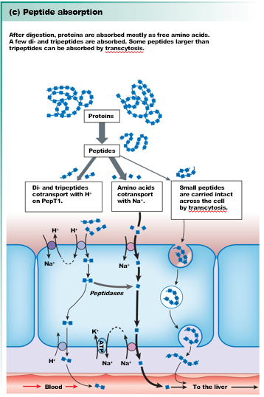

**HOW ABOUT ION AND WATER ABSORPTION**

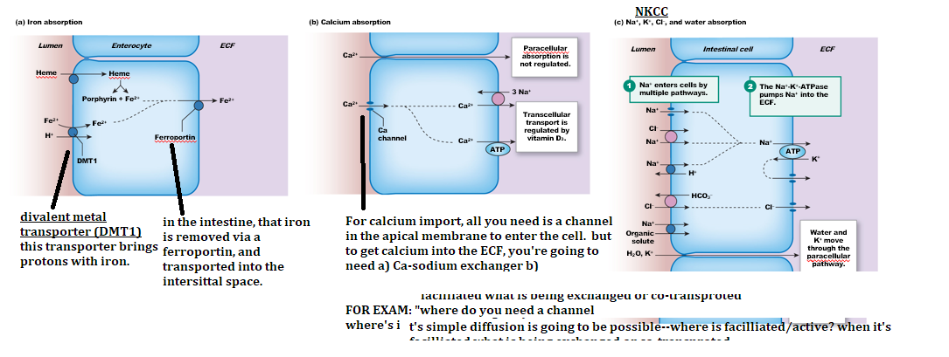

* We covered proteins, fatty, carb, ions, and the metal (iron)

FERROPORTIN (look at (A) **[EXAM EXAM]**

* The expression of ferroprotin and the ability of ferroprotin to allow for sodium diffusion is regulated by a LIVER secrection called **HEPSIDINE** [EXAMMAMAMMA]
  + **HEPSIDINE** + **FERROPROTI**N = NO IRON ABSORPTION
    - Hepsidine inhibits ferroprotin.
      * Iron absorption gets into the blood supply and it’s carried into the liver, but if there’s too much of iron the liver (hepatocyte) will secrete hepsidine and binds to ferroprotin, preventing iron-reabsorption.
        + E.g., self-protective mechanism from the liver for instance if you eat too much meat, but also because iron is not really that toxic (it is…?), but the most toxic thing that can do, the **strongest free radical** that can be generate is

IRON + VITAMIN C =>

Iron is actually wrapped up in a protein because the minute iron finds vitamin C, you get the strongest free radical.

LIPID SOLUBLE VITAMINS

* ABSORBED BY DIFFUSION, BUT THEY NEED TO BE BOUND TO LIPIDS
  + **VITAMINS A,D,E,K are cotransporter by simple diffusion with LIPIDS.** 
    - Because if you are in a diet with “fake fats” that cannot be absorbed,
      * The problem with this or **taking inhibitors or cholesterol INHIBITORS, THEN YOU NEED TO TAKE VITAMIN SUPPLEMENTATION**
        + Because you are going to become vitamin deficient otherwise.

B12:

* B12 is imported, but in order for it to diffuse into the body, it must be done so with an “intrinsic factor” secreted by gastric cells, by G-cells. **G-cells, turn on the absorption of B-12 in the intestines.** Without instrintic factor, we cannot absorb B12. So people with defiency of B12, then it’s really the inability to absorb B12.

Figure 21.20 Integration of gastric and intestinal phases

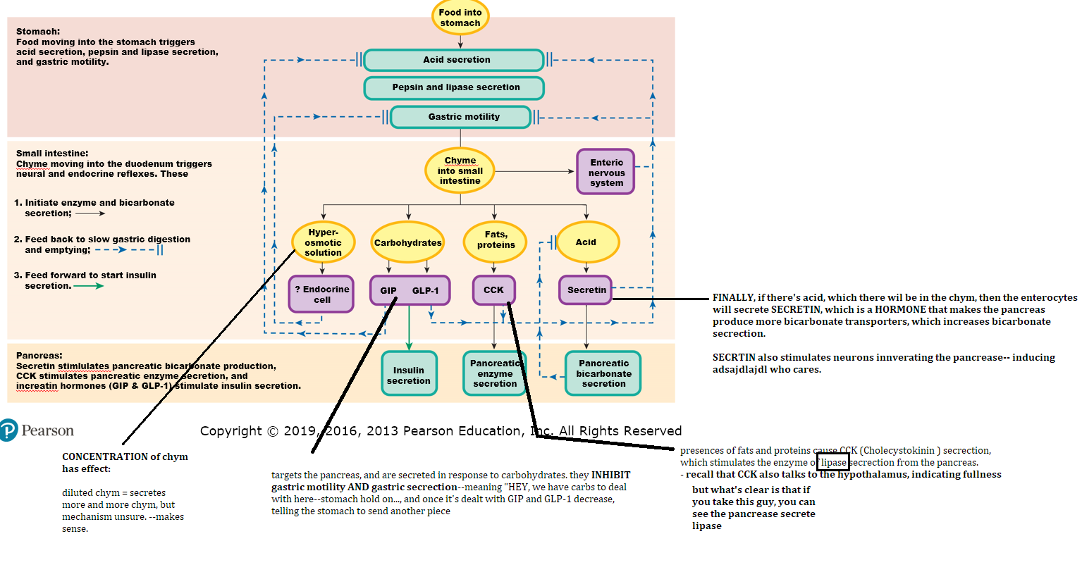

The Large Intestine Concentrates Waste

* Large intestine has LARGE single unit conctractiosn known as **haustra**.
* There is a sphincter separating the small intestine and large called the **ileum**
* IF YOU OPEN the intestine, and you look at the lining, it looks a lot like the small intestine EXCEPT THERE is no VILI.
  + There is flatness and pits.

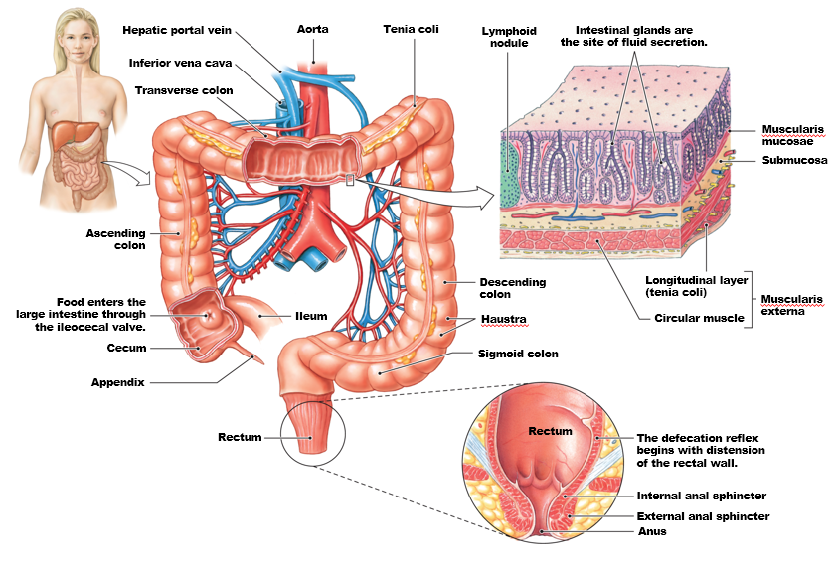

GOING BACK TO THE SMALL INTESTINE

* **PEYER PATCHES:** lymphoid cells(nodes) that are ENRICHED in B-lympocytes, and they form the GASTRIC ASSOCIATED LYMPHOID TISSUE (THE GOUT??)
  + 80% of lymph vessels and nodes are around the gastrointestinal.

**NOW IN THE LARGE INTESTINE** (back to present)

* You have in these peyer [EXAM] known as M-cells
  + **M-cells SPECIALIZE IN ENDOCYTOSIS, AND THEY present these cells on the other side and they function as ANTIGEN-PRESENTING CELLS that inform the immune system of pathogens present in the large intestine.**
* The segmental contraction in the small intestine, as you recall happen about 4cm/second, and the constanty of it means that there’s very little bacteria growing in the small intestine, but now they are now in the large intestine, and these bacteriasl ARE BEING “SAMPLED” BY **THE M-CELLS and presented to the other side. This generates immune reactions through the function of M-cells, what will happen now is WATER secrection.**
  + **Open of Cl- channels, floods into the lumen, water and sodium will follow through paracellular ways, and this will cause DIARRAEHA.** 
    - **THUS ACTIVATION OF M-CELLS CAUSES OPENING OF CHLORIDE CHANNELS—SO CHLORIDE IS SECRETED, SODIUM AND WATER FOLLOWS—LIQUIDFYING THE CHYM IN THE LARGE INTESITNE.** 
      * **This is a protective mechanism to flush pathogens.**
* Drop in blood volume, drop in blood pressure due to diarrhea. – make sure you continue to drink electrolytes when you have food poisoning.

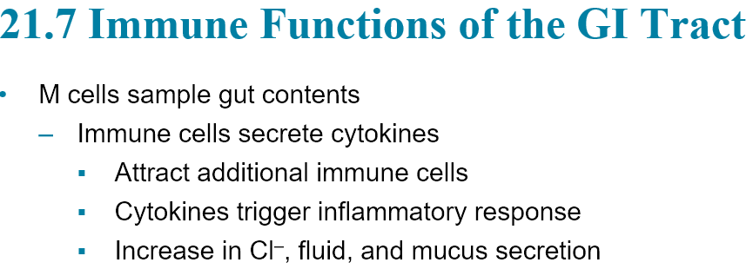

Vomiting – who fucking cares; something about overstretch fundus and serotonin secrection causes vomiting.

THE RECTUM IS EXACTLY LIKE THE BLADDER

* The micturition relax and the defectation reflex SHARE THE SAME REFLEX
  + The external sphincter is skeletal muscle.
* ACh SECRETED TO MOTOR NEURON CAUSES THE SPHINCTER TO REMAIN CONTRACTED, but the internal sphincter and the walls of rectum are smooth muscles innverated by stretch sensor, when they are stretched, they snypase to interneurons that that fire ACh through the efferent neuron.
  + ACh causes smooth muscle contract—defectation reflex.

